Document Type:  PROCEDURE |  | Unique Identifier:  CORP/PROC/592
Title:  Procedure For Anticipatory Prescribing For Palliative Care Patients using the Subcutaneous, as required and syringe Pump prescription and Administration Record (SPAR booklet) |  | Version Number:  3
Status:
Ratified
Scope:  Trust Wide |  | Classification:  Organisational
Author/Originator and title:  Dr Andrew Dickman – Consultant Pharmacist, Blackpool Teaching Hospitals NHS Foundation Trust  Dr Susan Salt – Consultant in Palliative Medicine and Medical Director Trinity Hospice |  | Responsibility:  Pharmacy
Replaces:  CORP/PROC/592 version 2 Procedure For Anticipatory Prescribing For Palliative Care Patients (Just In Case 4 Core Drugs)  NL/QSE/08/09, Version 1, Just In Case Drugs Policy in Community (North Locality Only) | Description of amendments:  Changes to SPAR booklet. Including change from diamorphine to morphine  Clarification around specialist medication used in community  Care for the Dying Person Guidance replaces Liverpool Care Pathway
Name Of:  Divisional/Directorate/Working Group:  Blackpool & Fylde Coast Health Care Economy Anticipatory Prescribing Review Group | Date of Meeting: | Risk Assessment:  Not Applicable
Financial Implications
Not Applicable
Validated by:  Adults and Long Terms Conditions Policies and Standards Group | Validation Date:  03/07/2015 | Which Principles of the NHS Constitution Apply?  Principle 1-4
Ratified by:  Medicines Management and Incident Review Committee | Ratified Date:  21/08/2015 | Issue Date:  21/08/2015
Review dates may alter if any significant changes are made |  | Review Date:  01/08/2018
Does this document meet the requirements of the Equality Act 2010 in relation to Race, Religion and Belief, Age, Disability, Gender, Sexual Orientation, Gender Identity, Pregnancy & Maternity, Marriage and Civil Partnership, Carers, Human Rights and Social Economic Deprivation discrimination? Initial Assessment

CONTENTS
1 PURPOSE 3
2 SCOPE 3
3 PROCEDURE 5
3.1 Known Risks 5
3.2 Professional Responsibilities 5
3.2.1 Prescriber: 5
3.2.2 Pharmacist 6
3.2.3 Nurse 6
3.3 ‘Just In Case 4 Core Drugs’ Required 7
3.4 Identification of patients for inclusion in the scheme 7
3.5 Prescribing and Authorisation in the community 8
3.6 Prescribing and Authorisation on discharge from hospital 8
3.7 Prescribing and Authorisation on discharge from Trinity Hospice 9
3.8 Transport of end of life drugs within the community 10
3.9 Record Keeping / Administration 10
3.10 Storage of Medicines 11
3.11 Disposal of Medicines 12
3.12 Monitoring 12
3.13 Performance Indicators 12
4 ATTACHMENTS 12
5 ELECTRONIC AND MANUAL RECORDING OF INFORMATION 13
6 LOCATIONS THIS DOCUMENT ISSUED TO 13
7 OTHER RELEVANT/ASSOCIATED DOCUMENTS 13
8 SUPPORTING REFERENCES/EVIDENCE BASED DOCUMENTS 14
9 CONSULTATION WITH STAFF AND PATIENTS 15
10 DEFINITIONS/GLOSSARY OF TERMS 15
11 AUTHOR/DIVISIONAL/DIRECTORATE MANAGER APPROVAL 16
Appendix 1: Subcutaneous ‘as required’ & Syringe Pump Prescription Administration Record (SPAR booklet) See separate document 17
Appendix 2: Pharmacy Collection and Delivery Form for the JiCDs 41
Appendix 3: Primary Care Flow Chart for the use of ‘Just in Case Four Core Drugs’ 42
Appendix 4: Flow Chart for ‘Just in Case Four Core Drugs’ in Hospital or Hospice 44
Appendix 5: Equality Impact Assessment Form 46

PURPOSE
Patients with palliative illness may experience new or worsening symptoms as their condition deteriorates. During the last weeks or days of life, when patients can no longer swallow their oral medication, delays in accessing appropriate non-oral medications could cause undue distress to both the patient and their carer.

This procedure aims to contribute to the delivery of optimal care to patients with palliative illness in the community, in line with the recommendations contained within the Care for the Dying Person Guidance and the Plan of Care for people approaching the last days and hours of life.

This procedure sets out steps for the prescribing, dispensing, storage, and disposal of medication prescribed in anticipation of need in patients with life limiting and progressive illnesses who are approaching the last months, weeks or days of their life when they may be no longer able to take oral medication.

Prescribers should anticipate common symptoms in the last weeks / days of life such as pain, breathlessness, secretions, nausea / vomiting and agitation.

- Prescribers should authorise administration of the appropriate medication by appropriately trained nurses.

- Prescribe sufficient quantities of the appropriate medication to cover those anticipated symptoms

- Pharmacists should ensure that such medication is dispensed in a timely fashion in advance of the need to administer the medicine.

- Prescriptions written must comply with current legislation and be clear as well as safe. Prescriptions should be written in such a way that they understood by healthcare staff responsible for dispensing and administering the medication using the Subcutaneous ‘As Required’ & Syringe Pump Prescription and Administration Record (SPAR) booklet.

- Carers and patients are re-assured that prescribed medicines are for ‘just in case’ and may not be needed and where appropriate given a “Just in Case” Medication leaflet (Appendix 3).

SCOPE
All patients, living in their own homes, with a progressive, life limiting illness, registered with a General Practitioner (GP) within Blackpool or Fylde and Wyre Clinical Commissioning Groups (CCGs), who have been assessed as in the last months / weeks or days of their life, may be included within this scheme. This will include patients with a poor prognosis, where the condition is unpredictable or is likely to deteriorate rapidly. Particular consideration should be given to those living in isolated situations or during extended holiday periods, where access to medication may be restricted.
It will also apply to patients cared for by community staff employed by Blackpool Teaching Hospitals NHS Foundation Trust who work with GPs from North Lancashire CCG who work in the Garstang area. In these circumstances the principles behind prescribing and administering Just in Case medication will be the same, however the actual medications prescribed “just in case” may include Cyclizine for nausea and /or vomiting rather than Levomepromazine.

It will also apply to patients cared for by community staff employed by Blackpool Teaching Hospitals NHS Foundation Trust who work with GPs from Greater Preston CCG who work in the Great Eccleston Area. In these circumstances the principles behind prescribing and administering Just in Case medication will be the same, however the actual medications prescribed “just in case” may include Cyclizine for nausea and /or vomiting rather than Levomepromazine and Hyoscine Hydrobromide rather than Glycopyrronium for respiratory tract secretions..

Additional consideration and further risk assessment may be required:

- Patients where there is a history or suspicion of drug misuse.

- Patients with family members, carers or visitors to the house where there is a history or suspicion of drug misuse.

- Patients where there is concern about the safe storage of the medication.

- Patients where there is concern about the medication being accessed by children or other vulnerable members of the household.

- Patients where there are concerns about the mental well-being of a member of the patient’s household or regular visitor where access to a controlled drug could be contra-indicated such as suicidal ideation.

In these situations each case must be individually reviewed and a risk assessment (see appendix 2 in CORP/PROC/452 “Policy for Anticipatory Prescribing for Palliative Care Patients (Just in Case 4 Core Drugs)) carried out by a senior member of the community team before a decision is made after a multi-disciplinary discussion which should involve as a minimum.

- Patient’s GP
- Senior District Nurse
- Specialist in Palliative Care
- (Drug support worker if involved)

It is anticipated that in most cases the decision will made be to provide just in case or end of life medication but that additional safeguards may be needed such as more frequent checking or adjusting the timing of such medication being placed in the household.

The decision and risk assessment should be reviewed on a regular basis, the frequency of which will depend on the individual patient and rate of deterioration.

Exclusions
Patients who themselves are unwilling to participate or carers who are unwilling to participate. If there are concerns advice should be sought from the Specialist Palliative Care Services i.e. Trinity Hospice, Blackpool, St John’s Hospice, Lancaster or St Catherine’s Hospice, Preston.

PROCEDURE

Known Risks
As with all drugs open to abuse, medicine supplies in patients’ houses may be subject to misuse. (An untoward incident report (CORP/PROC/101) must be completed if there is suspicion of misuse).

- Opioid toxicity due to inappropriate dose being administered. Most patients requiring the “Just in Case Four Core Drugs” will be opioid tolerant so the risk of overdose is small. In the rare instance of a suspected opioid overdose, seek medical advice. (An untoward incident report (CORP/PROC/101) must be completed if there is suspicion that opioid doses have resulted in toxicity.

- Undue sedation due to use of midazolam and / or combination of midazolam and opioid. In the rare instance of suspected over sedation seek medical advice. (An untoward incident report (CORP/PROC/101) must be completed if there is suspicion of over sedation due to medication).

- Safe disposal of unused vials of either JiCD and EoLAD after the death of an individual in their own home relies on a carer returning the unused vials to a community pharmacy for safe disposal. Whilst this can be encouraged it cannot be guaranteed.

- Medication may reach expiry date before it is needed. It is essential that medication is regular checked to ensure it is within date. This is particularly important prior to holiday periods or where an individual lives in a relatively isolated location.

Professional Responsibilities
Refer to Appendices 4 and 5 for further information.

Prescriber:
- If the prescriber is not the patient’s General Practitioner (GP), it is the prescriber’s responsibility to inform the patient’s own GP of the presence of SPAR booklet and either Just in Case or End of life anticipatory medication.

- Ensure the patient / family have been included in any decisions to prescribe and informed about the medication being dispensed and reasons behind them being available when needed.

- Prescribe the agreed medicines on the appropriate documents:

- in community - FP10.

- in hospice – hospice FP10 prescription for controlled drugs and hospice discharge prescription pad.

- in hospital – paper discharge prescription (for controlled drugs) and e-discharge.

- Ensure that prescriptions comply with current legislation.

- Complete ALL the relevant section of the SPAR booklet.

- Ensure that Primary Care and Out of Hours services are aware of the presence of Just in Case or End of Life anticipatory medication.

- Ensure that the Community Nurse is informed of the need for Just in Case or End of Life anticipatory medication.

- Ensure that anticipatory medication is reviewed regularly, at least fortnightly, and after any known change in circumstances.

Pharmacist
- Dispense the prescription in line with the agreed policy and in line with current legislation.

- Provide appropriate patient information (package inserts) and maintain records to ensure effective on-going service delivery and audit.

- Keep relevant records of collection and delivery.

- Destroy any returned drugs as per local policy.

If a designated pharmacy for dispensing the four core Just In Case Drugs comply with guidance in CORP/PROC/452 and Service Level agreement with appropriate CCG.

Nurse
- Explain the purpose of the Just in Case or End of Life anticipatory medication to patient, family and carers, using patient information leaflet (Appendix 3).

- Ensure the patient and carer know who to contact out of hours should any symptoms or problems occur.

- In exceptional circumstances only, act as the patient representative for collection of JiCDs if it is deemed appropriate as per Nurse and Midwifery Council (NMC) Guidelines 2010 (proof of identity will be required).

- Inform the prescriber when additional supplies of medication are required.

- Facilitate the destruction of Controlled Drugs (CDs) after the patient’s death as per local guidance by reminding relatives of the need to return the medication to a pharmacy for safe destruction

‘Just In Case 4 Core Drugs’ Required

Drug | Formulation | Size of ampoule | Amount to prescribe
Morphine  for pain | 10 mg/1ml amp | 2ml amps | If opioid naïve:  5 amps  If previously on opioids:  5 days’ supply  Contact specialist palliative care for advice if unsure of amount
Levomepromazine  for nausea and vomiting | 25 mg/1mL | 1mL amps | 5 amps
Midazolam  for agitation and terminal restlessness | 5 mg/mL  (= 10mg/2mL) | 2 mL amps | 5 amps  As per NPSA alert take care with these high strength amps
Glycopyrronium  for respiratory tract secretions | 200 microgram/1mL | 1mL amps | 5 amps
Water for Injections  Diluent |  | 10 mL amps | 10 amps

Identification of patients for inclusion in the scheme
All Healthcare Professionals will identify relevant patients ahead of need and include the patient / family in any decisions to prescribe either Just in Case 4 Core Drugs (JiCDS) (CORP/PROC/452) or anticipatory drugs at end of life (EoLAD).

A flow chart of the process can be seen in Appendices 4 and 5.

NB: All medications are prescribed for the named patient only and should never be used for any other patient.

Prescribing and Authorisation in the community
- The prescriber will prospectively prescribe the appropriate medications (as outlined above) on an FP10 (identifying it as part of the scheme by noting JiCD on the prescription where appropriate).

- Complete the appropriate sections of the “Subcutaneous ‘as required’ and Syringe Pump Prescription Administration Record (SPAR booklet)” legibly providing appropriate doses of medication to manage both actual and anticipated symptoms (Appendix 1).

- In the case of patient intolerance of one of the four core drugs, alternative medications may be prescribed (see Lancashire and South Cumbria Specialist Palliative Care Services Guidelines, CORP/GUID/143 (www.healthcare.trinityhospice.co.uk for more details).

- Where alternative drug(s) are needed they should be prescribed on the relevant blank pages within the SPAR booklet. Where appropriate, and for clarity pages with alternative medication for the same symptom as one of the four core drugs, the page for the core drug should be clearly crossed through with a note to see relevant page of the SPAR booklet where the alternative medication has been prescribed.

- When highly specialised medication has been recommended by the specialist palliative care service to maintain symptom control within the community at end of life, the appropriate specialist prescription pages should be completed in the SPAR booklet and an agreed way of working between the primary care team and specialist service established dependent on the individual patient. This will mainly (but not exclusively) cover:

- Octreotide
- Alfentanil
- Ketamine
- Methadone
- Hyoscine hydrobromide.

Prescribing and Authorisation on discharge from hospital
- The prescriber will ensure a paper discharge prescription for the appropriate controlled drugs is written in a timely manner.

- Complete the appropriate sections of the “Subcutaneous ‘as required’ and Syringe Pump Prescription Administration Record (SPAR booklet)” legibly providing appropriate doses of medication to manage both actual and anticipated symptoms (Appendix 1).

- Where alternative drug(s) are needed they should be prescribed on the relevant blank pages within the SPAR booklet. Where appropriate, and for clarity pages with alternative medication for the same symptom as one of the four core drugs, the page for the core drug should be clearly crossed through with a note to see relevant page of the SPAR booklet where the alternative medication has been prescribed.

- The patient’s primary care team including both the District Nurse and GP should be informed of the presence of the SPAR booklet and end of life medications

- Unless the patient is already on a continuous subcutaneous infusion (CSCI) only the as needed (PRN) doses of the core symptom control drugs should be prescribed in the SPAR booklet

- The medication in clearly labelled sealed boxes should be sent home with the patient as per standard discharge procedure.

Prescribing and Authorisation on discharge from Trinity Hospice
- The prescriber will ensure a FP10 discharge prescription for controlled drugs and hospice paper discharge prescription is written in a timely manner.

- Where alternative drug(s) are needed they should be prescribed on the relevant blank pages within the SPAR booklet. Where appropriate, and for clarity pages with alternative medication for the same symptom as one of the four core drugs, the page for the core drug should be clearly crossed through with a note to see relevant page of the SPAR booklet where the alternative medication has been prescribed.

- Complete the appropriate sections of the “Subcutaneous ‘as required’ and Syringe Pump Prescription Administration Record (SPAR booklet)” legibly providing appropriate doses of medication to manage both actual and anticipated symptoms (Appendix 1).

- The patient’s primary care team including both the District Nurse and GP should be informed of the presence of the SPAR booklet and end of life medications

- The medication in clearly labelled sealed boxes should be sent home with the patient as per standard discharge procedure

- When highly specialised medication has been recommended by the specialist palliative care service to maintain symptom control within the community at end of life, the appropriate specialist prescription pages should be completed in the SPAR booklet and an agreed way of working between the primary care team and specialist service established dependent on the individual patient. This will mainly (but not exclusively) cover:

- Octreotide
- Alfentanil
- Ketamine
- Methadone
- Hyoscine hydrobromide.

Transport of end of life drugs within the community
The anticipatory end of life medication should be collected from the dispensing pharmacy by the patient’s representative (with identification checked by the pharmacist) or delivered to the patient’s home by the pharmacy. In the case of the “Just in Case drugs” from a designated pharmacy these will be in a sealed tamper proof bag with the patients name, date of supply, drug name, quaintly supplied and batch numbers clearly displayed on the outside of the bag.

- The quantity of drugs dispensed must be entered on the pharmacy collection and delivery form (see Appendix 2) and this must be signed and dated by the person collecting the medicines.

It is normally the responsibility of the patient / relative / carer to arrange for dispensed medicines to be collected from or delivered by the pharmacy on receipt of the patient’s prescription. Community nurses are not authorised to carry CDs except in exceptional circumstances (when evidence of identification will be needed), as defined below. These exceptional circumstances are confined to situations:

- Where either patient’s, their carers or representatives are unable to collect the medicines, and no pharmacy delivery service is available and.

- Only when failure to transport the medicines would create an unacceptable delay in a patient receiving their prescribed therapy and should be reserved for use only in palliative care situations.

- CDs must be transported in a locked car boot directly from the pharmacy to the patient’s home on an uninterrupted journey, and must never be left unattended under any circumstances.

Record Keeping / Administration
- The Community Nurse will explain to the patient and carers the purpose of the JiCDs and that all items are for use by health care professionals only. A member of the community nursing team will check that a leaflet about the JiCDs has been provided and if not will ensure that one is given as soon as possible (Appendix 3).

- The Community Nurse will ensure that the patient and carer know how to contact Community Nursing services during both in- and out-of-hours periods.

- Should the patient’s condition deteriorate, they should be reassessed by a Doctor and the appropriate drugs prescribed as indicated.

- The SPAR booklet (Appendix 1) should be completed each time a drug is administered. It should remain with and follow the patient if they are transferred into another care setting.

- Whenever one of the JiCDs is used, the Community Nurse must inform the prescriber in order that arrangements can be made for additional supplies to be ordered and dispensed, if needed.

- If part of a vial is given to the patient, the community nurse should record the amount given and the amount wasted on the SPAR booklet e.g. if the patient is prescribed morphine 5mg and only the 10mg preparation is available, the record should show, “5mg given and 5mg wasted”.

- The quantity of each drug must be counted and recorded on the SPAR booklet consistently each time it is used.

- If the patient is admitted into a care home the administration record should go with the patient and continue to be used, in addition to any required care home documentation.

- If the patient is admitted into hospital/hospice the administration record must go with the patient, filed in their records while admitted (drugs will be transcribed onto hospital / hospice drugs charts) and be amended prior to discharge back to the community.

- Following the patient’s death, any remaining drugs must be returned to a local pharmacy and destroyed according to local guidance.

- Following the patient’s death , the “Subcutaneous ‘as required’ and Syringe Pump Prescription Administration Record (SPAR booklet)” must be filed in the health records of the care setting within which the patient died for the period specified in Records Management NHS Code of Practice Part 2 (2nd Edition) 2009.

Storage of Medicines
- The patient and carer should be informed that the JiCDs are prescription only medication and that they should be securely stored in a cool, dry place out of direct sunlight, not in public view and out of the reach of children.

- The supply of end of life medication must be checked to ensure nothing has been removed, used or expired without a record being made:

- For the sealed tamper proof Just in Case medication a check should be made at least every four weeks. If there is no evidence of tampering, no further action is needed. Record check made in nursing notes

- At every visit if the bag has been opened the medication should be inspected and counted to ensure all drugs supplied can be accounted for.

- If the nurse cannot account for all of the controlled drugs, after enquiry with the family and health care team, the team leader / manager must inform the Accountable Officer and complete an untoward incident form.

Disposal of Medicines
- Prescribed drugs, including controlled drugs (CDs), are the property of the patient and remain so even after death. However, it is illegal for a person to possess CDs that have not been prescribed for them (NPC, 2009, p.78).

- Any CDs remaining after a patient’s death must be destroyed as per local policy.

- Sharps bins should be disposed of as per local policy.

- If a patient is admitted to a Hospice, Hospital or Care Home the JiCDs, together with the Subcutaneous ‘as required’ and Syringe Pump Prescription Administration Record (SPAR booklet) should be taken with them. The drugs should be used or destroyed according to local procedure.

Monitoring
- Managers must ensure that all staff who are engaged with any activity covered by this procedure receive the appropriate training and supervision and are competent to carry out the work.

- Incident reports relating to this procedure will be made available.

- The Subcutaneous ‘as required’ and Syringe Pump Prescription Administration Record (SPAR booklet) should be retained in the hospice, hospital or community nursing records (depending upon where the patient dies) for the period specified in Records Management NHS Code of Practice Part 2 (2nd Edition) 2009.

- The Feedback form (Appendix 6) should be completed by the community nurse involved in the patient’s care and returned to the address on the form.

Performance Indicators
- The current version of this document will be made available on the intranet.
- At implementation, the procedure will be an agenda item on all clinical staff meetings.
- This procedure will be reviewed every three years

ATTACHMENTS
Appendix Number | Title
1 | Subcutaneous ‘as required’ and Syringe Pump Prescription Administration Record (SPAR booklet)
2 | Pharmacy Collection and Delivery Form
3 | Primary Care Flow Chart for ‘Just in Case Four Core Drugs’
4 | Flow Chart for ‘Just in Case Four Core Drugs’ in Hospital or Hospice
5 | Equality Impact Assessment Form

ELECTRONIC AND MANUAL RECORDING OF INFORMATION
Electronic Database for Procedural Documents
Held by Policy Co-ordinators/Archive Office

LOCATIONS THIS DOCUMENT ISSUED TO
Copy No | Location | Date Issued
1 | Intranet | 21/08/2015
2 | Wards, Departments and Service | 21/08/2015

OTHER RELEVANT/ASSOCIATED DOCUMENTS
Unique Identifier | Title and web links from the document library
CHS/POL/001 | Infection Prevention in the Community Setting  http://fcsharepoint/trustdocuments/Documents/CHS-POL-001.docx
CHS/POL/003 | Non Medical Prescribing  http://fcsharepoint/trustdocuments/Documents/CHS-POL-003.docx
CHS/SOP/009 | Supply and Administration of Controlled Drugs via a Syringe Driver in a Patient’s Premises  http://fcsharepoint/trustdocuments/Documents/CHS-SOP-009.docx
CORP/GUID/143 | Palliative Care Prescribing: Lancashire and South Cumbria Specialist Palliative Care Services 2014  http://fcsharepoint/trustdocuments/Documents/CORP-GUID-143.pdf
CORP/GUID/145 | Care for the Dying Person Interim Guidance  http://fcsharepoint/trustdocuments/Documents/CORP-GUID-145.docx
CORP/POL/056 | Hand Hygiene Policy  http://fcsharepoint/trustdocuments/Documents/CORP-POL-056.doc
CORP/POL/116 | Infection Prevention Policy  http://fcsharepoint/trustdocuments/Documents/CORP-POL-116.doc
CORP/POL/509 | Non-Medical Prescribing  http://fcsharepoint/trustdocuments/Documents/CORP-POL-509.doc
CORP/PROC/101 | Untoward Incident and Serious Incident Reporting  http://fcsharepoint/trustdocuments/Documents/CORP-PROC-101.docx
CORP/PROC/302 | Controlled Drugs – Safer Management of Controlled Drugs  http://fcsharepoint/trustdocuments/Documents/CORP-PROC-302.docx
CORP/PROC/418 | Hand Hygiene Procedure  http://fcsharepoint/trustdocuments/Documents/CORP-PROC-418.doc
CORP/PROC/452 | Policy for Anticipatory Prescribing for Palliative Care Patients (Just in Case 4 Core Drugs)  http://fcsharepoint/trustdocuments/Documents/CORP-POL-452.docx
CORP/PROC/567 | Health Record – Basic Clinical Record Keeping Standards  http://fcsharepoint/trustdocuments/Documents/CORP-PROC-567.doc
CORP/PROC/583 | Safe disposal of all medicines  http://fcsharepoint/trustdocuments/Documents/CORP-PROC-583.doc
CORP/PROC/577 | Use of CME T34 Syringe Pump for Adult Patients  http://fcsharepoint/trustdocuments/Documents/CORP-PROC-577.doc
CORP/PROT/001 | Non-medical prescribing Protocol and Policy  http://fcsharepoint/trustdocuments/Documents/CORP-PROT-001.DOCX

SUPPORTING REFERENCES/EVIDENCE BASED DOCUMENTS
References In Full
Amass, C. and Allen, M. (2005) How a ‘Just in Case’ Approach can Improve Out-of-Hours Palliative Care Pharmaceutical Journal 275: 22
Amass, C. (2006) The Gold Standards Framework for Palliative Care in the Community. Pharmaceutical Journal 276: 353-354
Blackburn with Darwen and East Lancashire PCTs (2009) East Lancashire Guidelines For The Management Of Symptoms In The Last Days Of Life
Cambridgeshire Community Services NHS Trust (2010) Policy for Anticipatory Prescribing For Patients with a Terminal Illness
Department of Health (2004) Delivering the Out-of-Hours Review: Securing proper access to medicines in the out-of-hours period - a practical guide for PCTs and organised providers
Department of Health (2006) Safer Management Of Controlled Drugs:
Guidance On The Destruction And Disposal Of Controlled Drugs (Interim Guidance) Gateway Reference: 7186
Department Of Health (2008) End of life Care strategy
Gold Standards Framework GSF) Online. Birmingham. Available at http://www.goldstandardsframework.nhs.uk accessed on 11 February 2011
Lancashire and South Cumbria Cancer Network (2012) Palliative Care Prescribing
National Institute for Clinical Excellence (2004) Improving Supportive and Palliative Care for Adults with Cancer
National Patient Safety Agency (2008). Reducing Dosing Errors with Opioid Medicines NPSA/2008/RRR005
National Patient Safety Agency (2008). Reducing risk of Overdose with Midazolam Injection in Adults NPSA/2008/RRR011
National Patient Safety Agency (2010). Safer Ambulatory Syringe Drivers NPSA/2010/RRR019
National Prescribing Centre (2009) A Guide to Good Practice in the Management of Controlled Drugs in Primary Care. 3rd edition. London: Department of Health
Nursing and Midwifery Council (NMC) (2010) Standards for Medicines Management. London: NMC

CONSULTATION WITH STAFF AND PATIENTS
Name | Designation
Dr Susan Salt | Medical Director, Trinity Hospice and Palliative Care Services
Dr Laura Edwards | Community Consultant in Palliative Medicine, Trinity Hospice and Palliative Care Services
Dr Andrea Whitfield | Hospital Consultant in Palliative Medicine, Blackpool Teaching Hospitals NHS Foundation Trust
Dr Meenakshi Varia | GP and Macmillan GP Facilitator, NHS North Lancs (Wylde) and Trinity Hospice and Palliative Care Services
Dr Michelle Martin | GP and Macmillan GP Facilitator, NHS Blackpool and Trinity Hospice and Palliative Care Services
Kathryn Smith | Fylde Coast EOL Project lead
Vivienne Trott | End of Life facilitator, Trinity, Fylde and Wyre
Lisa Drinkwater | Fylde and Wyre CCG Development Pharmacist
Lynn Atcheson | Clinical development lead-community
Janet Purdie | End of Life Lead Blackpool
Annette Ramesh | Team Leader DN Fleetwood
Dr Tony Naughton | Chair, Fylde and Wyre Clinical Commissioning Group
Dr Adam Janjua | End of Life Lead, Fylde and Wyre Clinical Commissioning Group
Dr Stephen Hardwick | Fylde and Wyre Clinical Commissioning Group
Jan Bamber | Non-Prescribing Lead, Blackpool Teaching Hospitals NHS Foundation Trust
Wendy Lambert | Lead Nurse FCMS
Gill Speight | Head Of North Locality, Community Nursing

DEFINITIONS/GLOSSARY OF TERMS
CCGs | Clinical Commissioning Groups
CDs | Controlled Drugs
CSCI | continuous subcutaneous infusion
EoLAD | anticipatory drugs at end of life
GP | General Practitioner
JiCDs | Just in Case 4 Core Drugs
NMC | Nurse and Midwifery Council
PRN | only the as needed
SPAR | Subcutaneous ‘As Required’ & Syringe Pump Prescription and Administration Record

AUTHOR/DIVISIONAL/DIRECTORATE MANAGER APPROVAL
Issued By | Dr Andrew Dickman | Checked By | A Gibson
Job Title | Consultant Pharmacist, Palliative Care | Job Title | Director of Pharmacy
Date | August 2015 | Date | August 2015

Appendix 1: Subcutaneous ‘as required’ & Syringe Pump Prescription Administration Record (SPAR booklet) See separate document
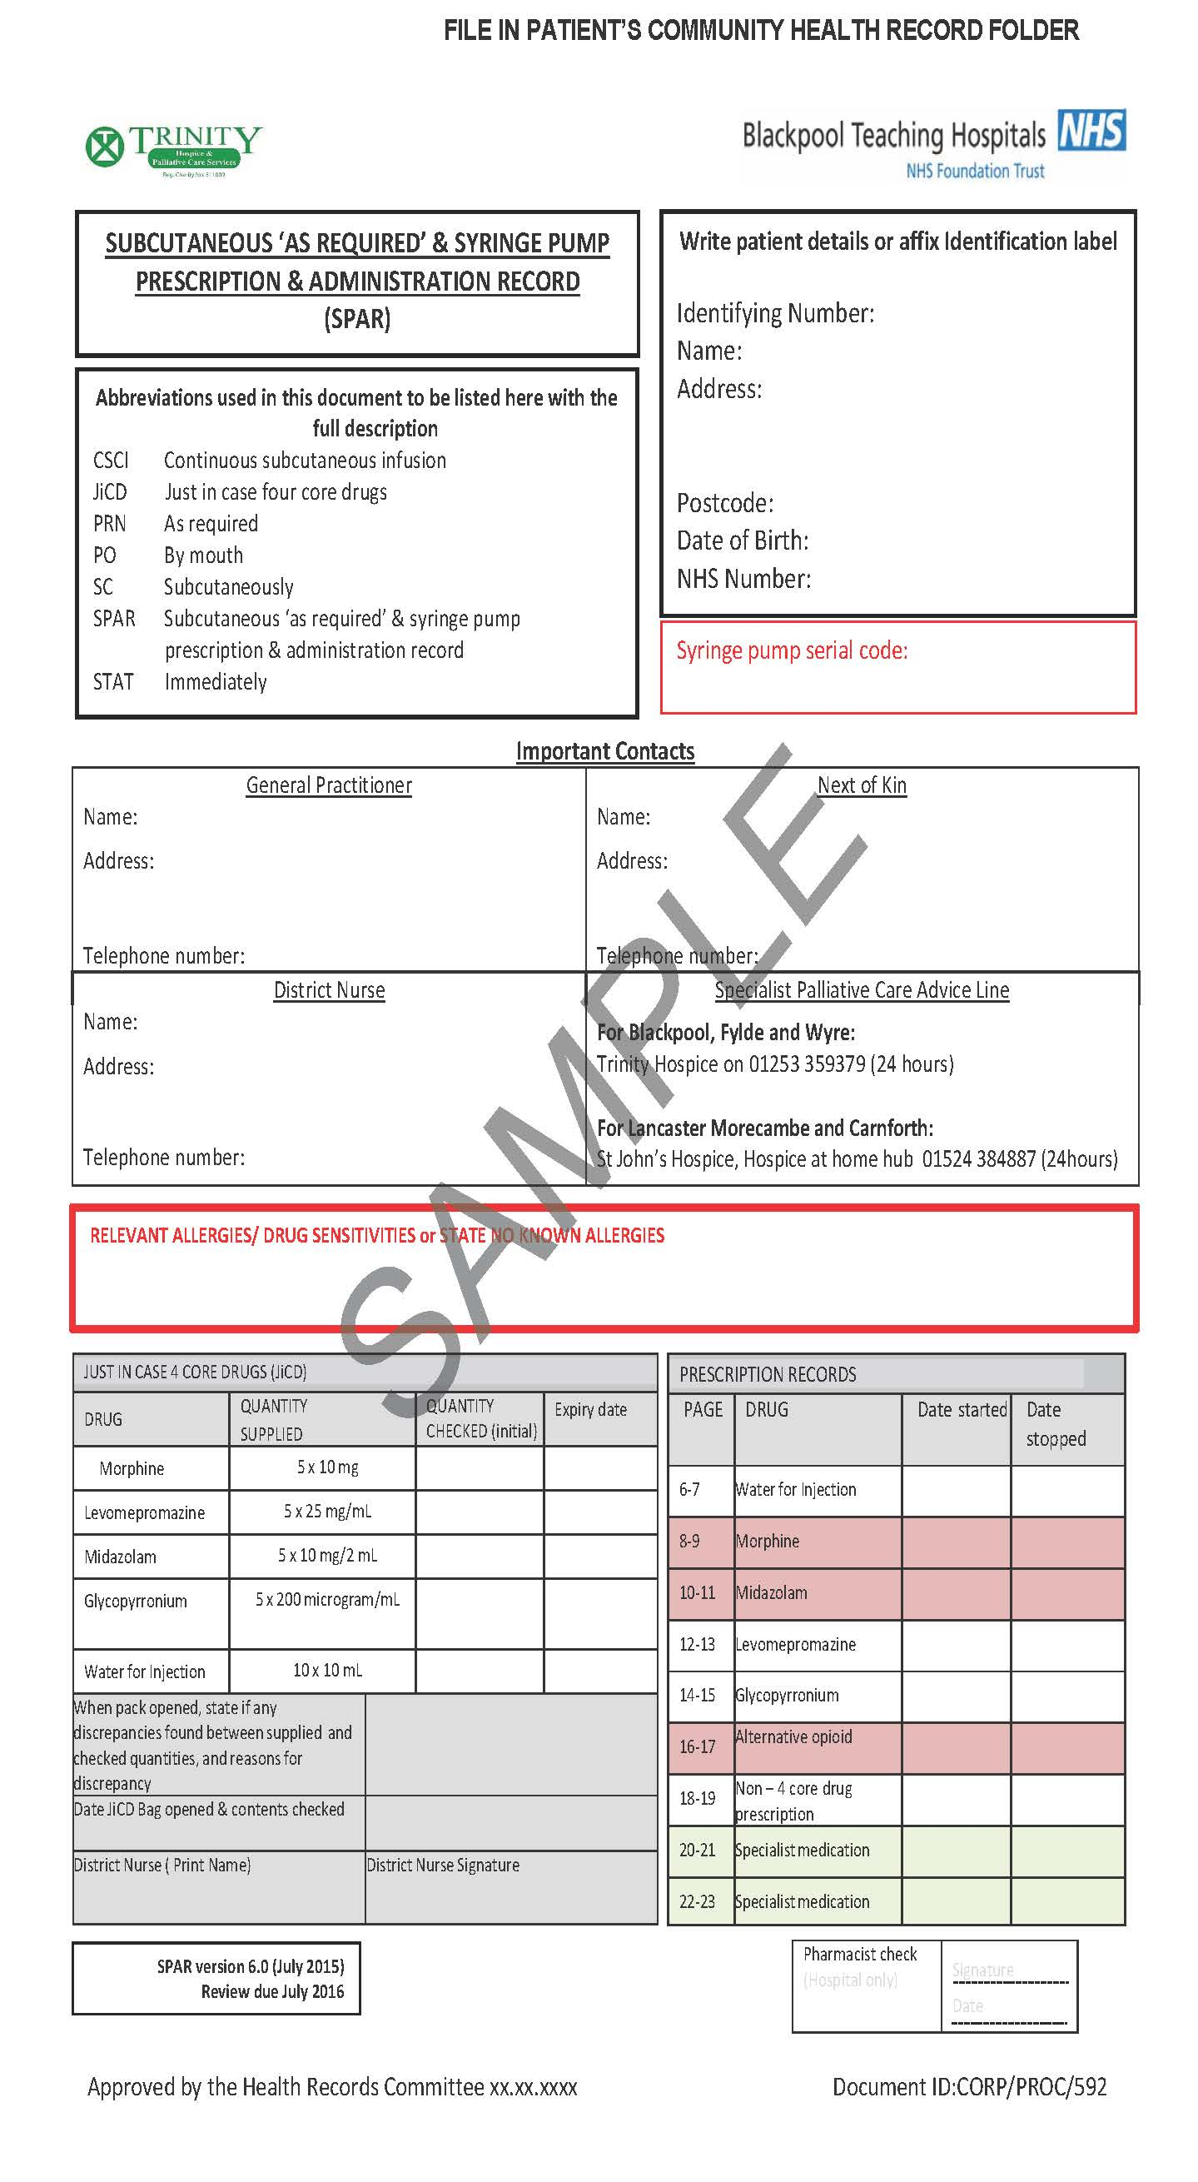
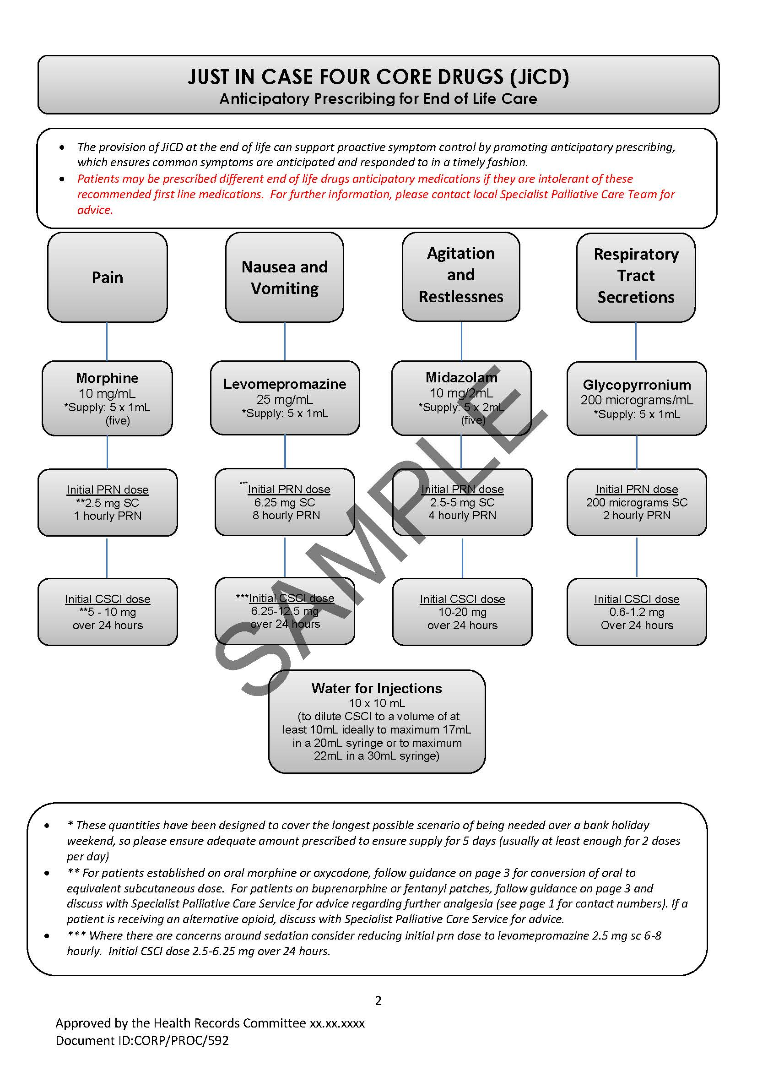
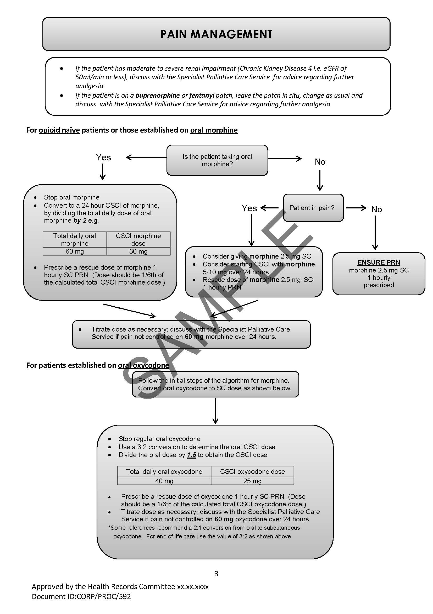
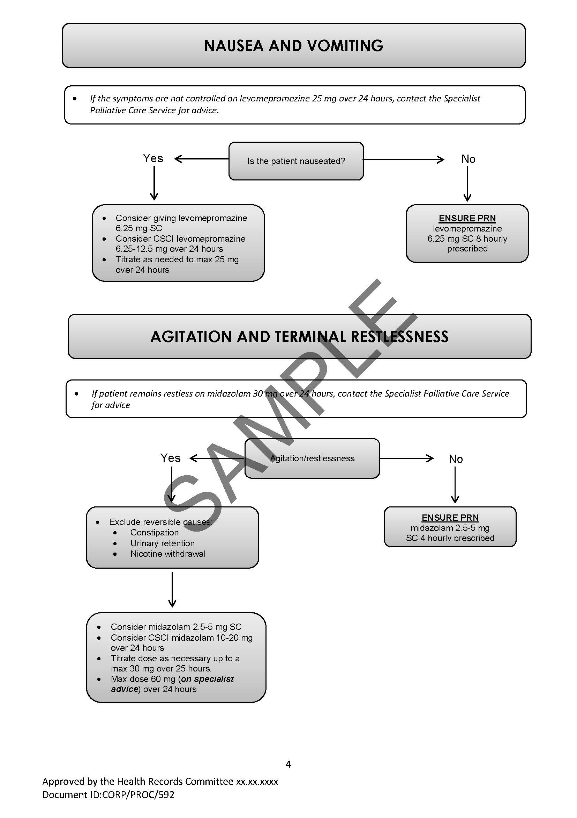
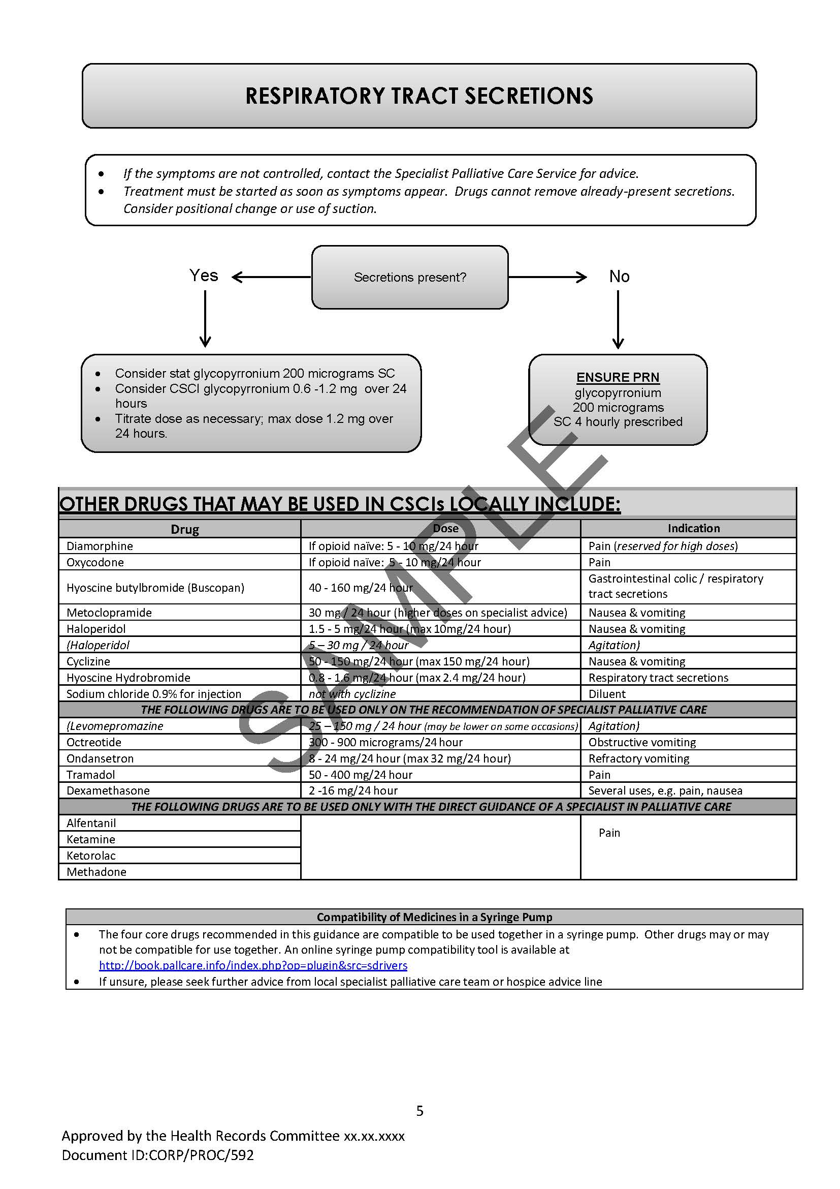

Appendix 1: Subcutaneous ‘as required’ & Syringe Pump Prescription Administration Record (SPAR booklet) See separate document
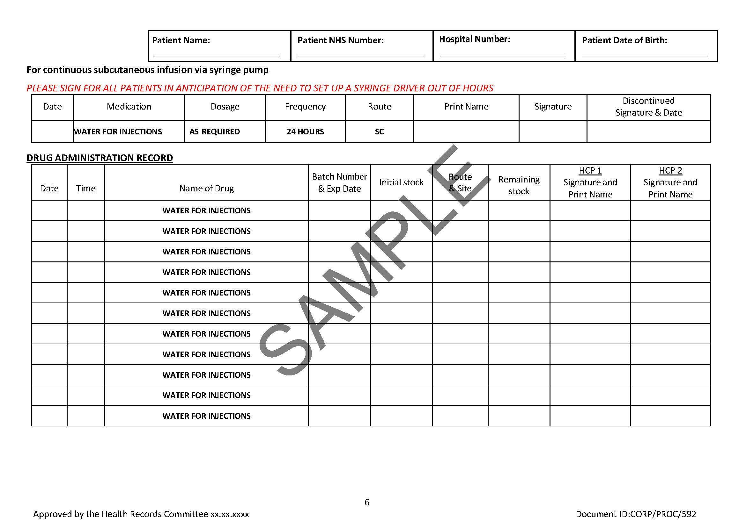
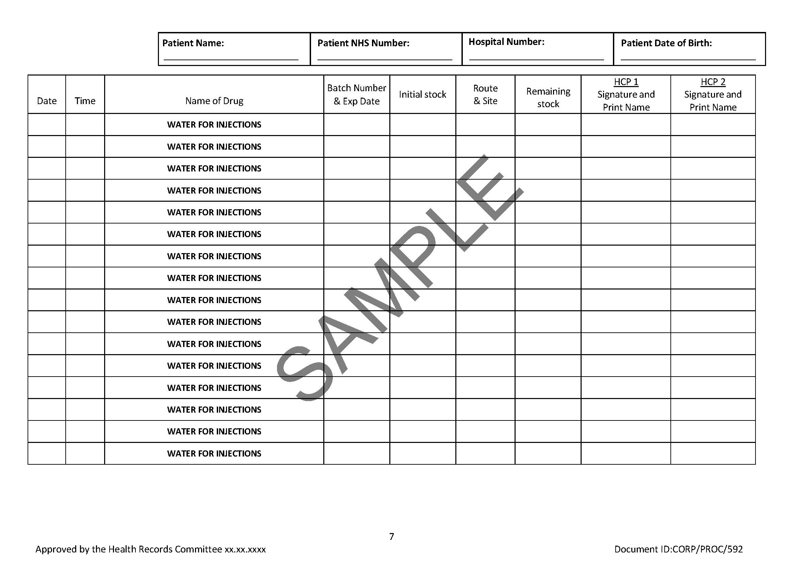
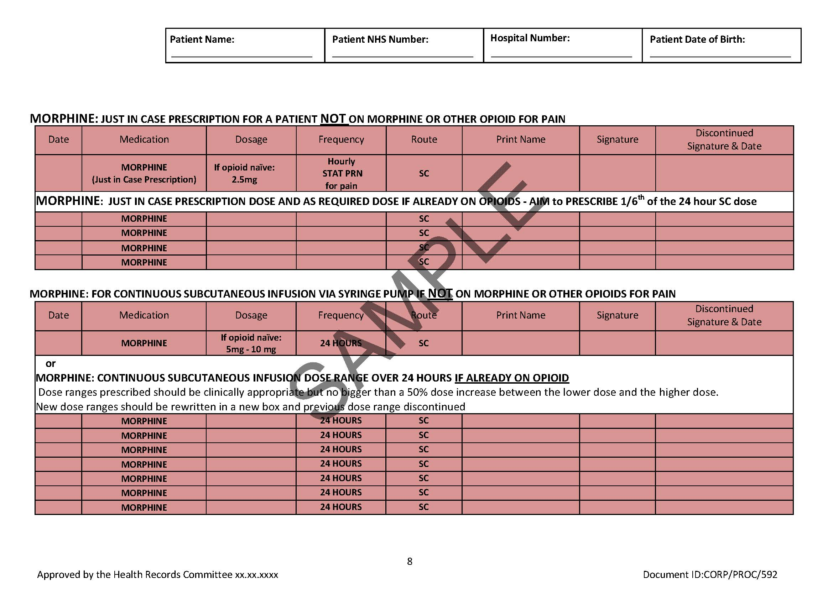
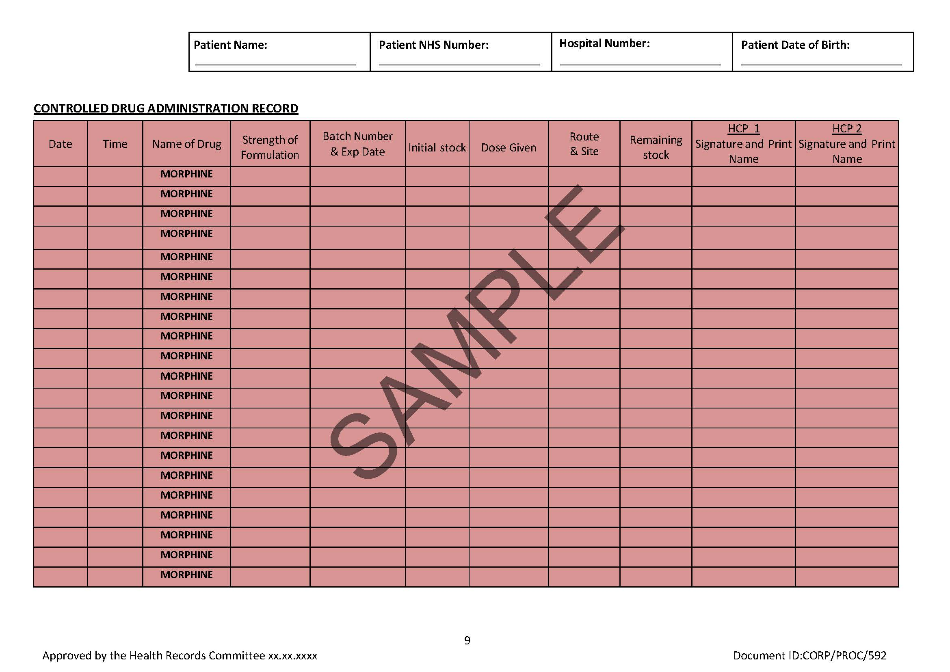
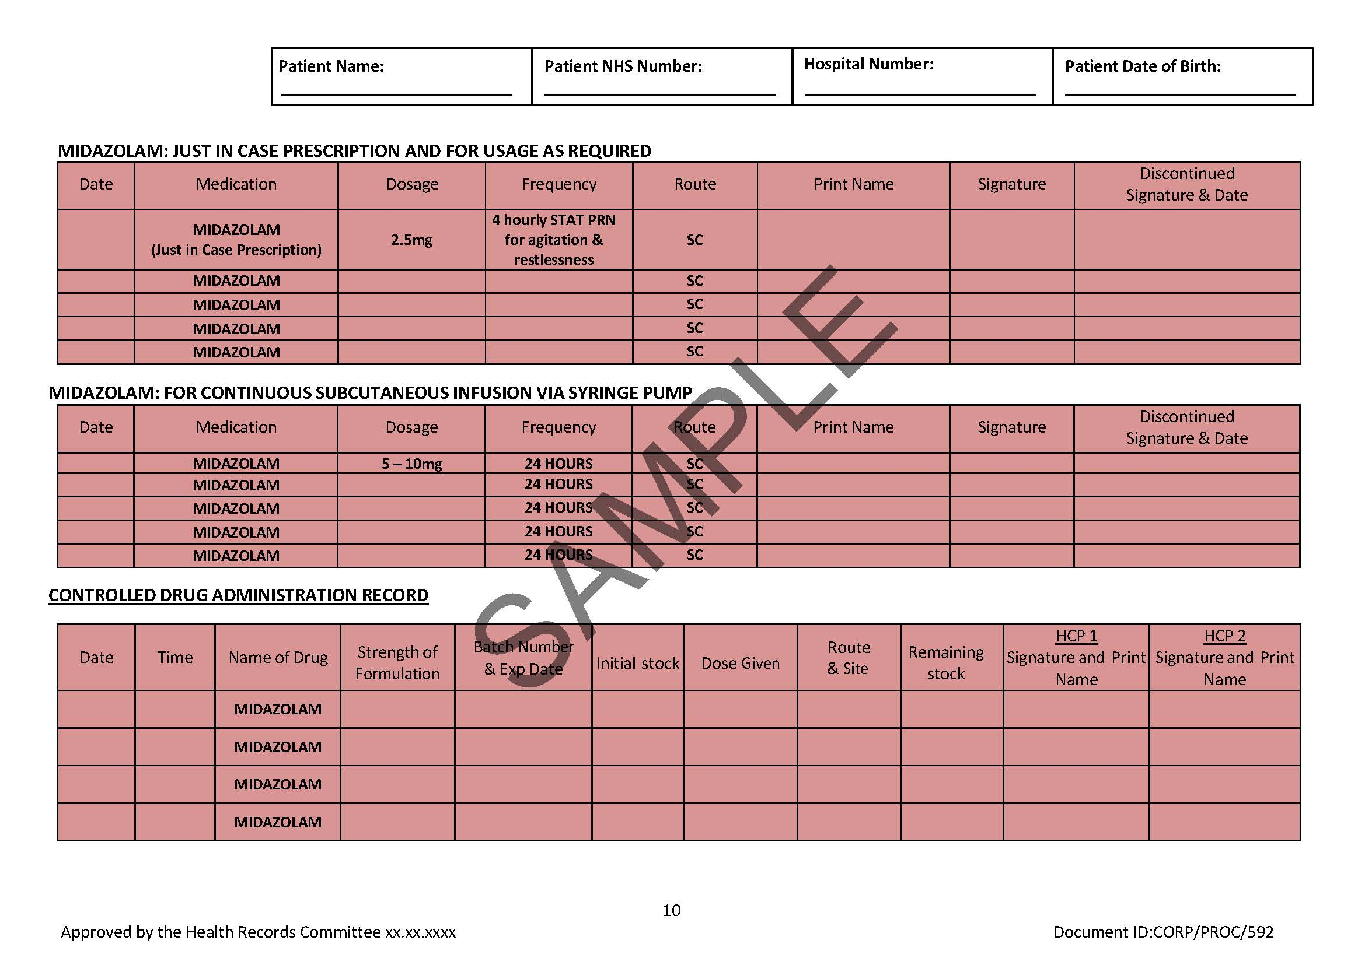
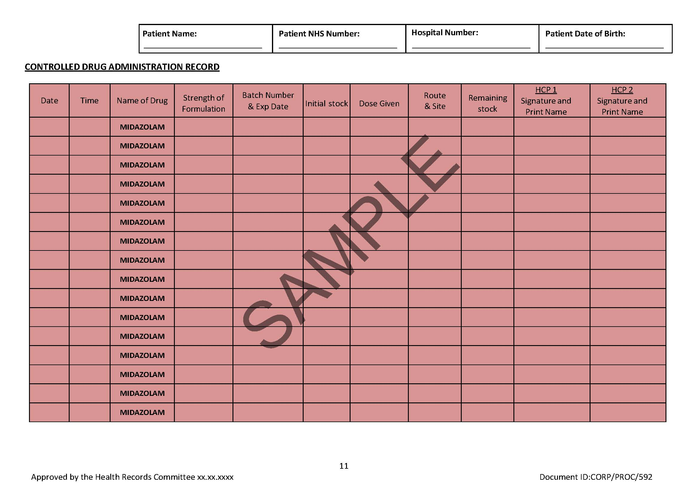
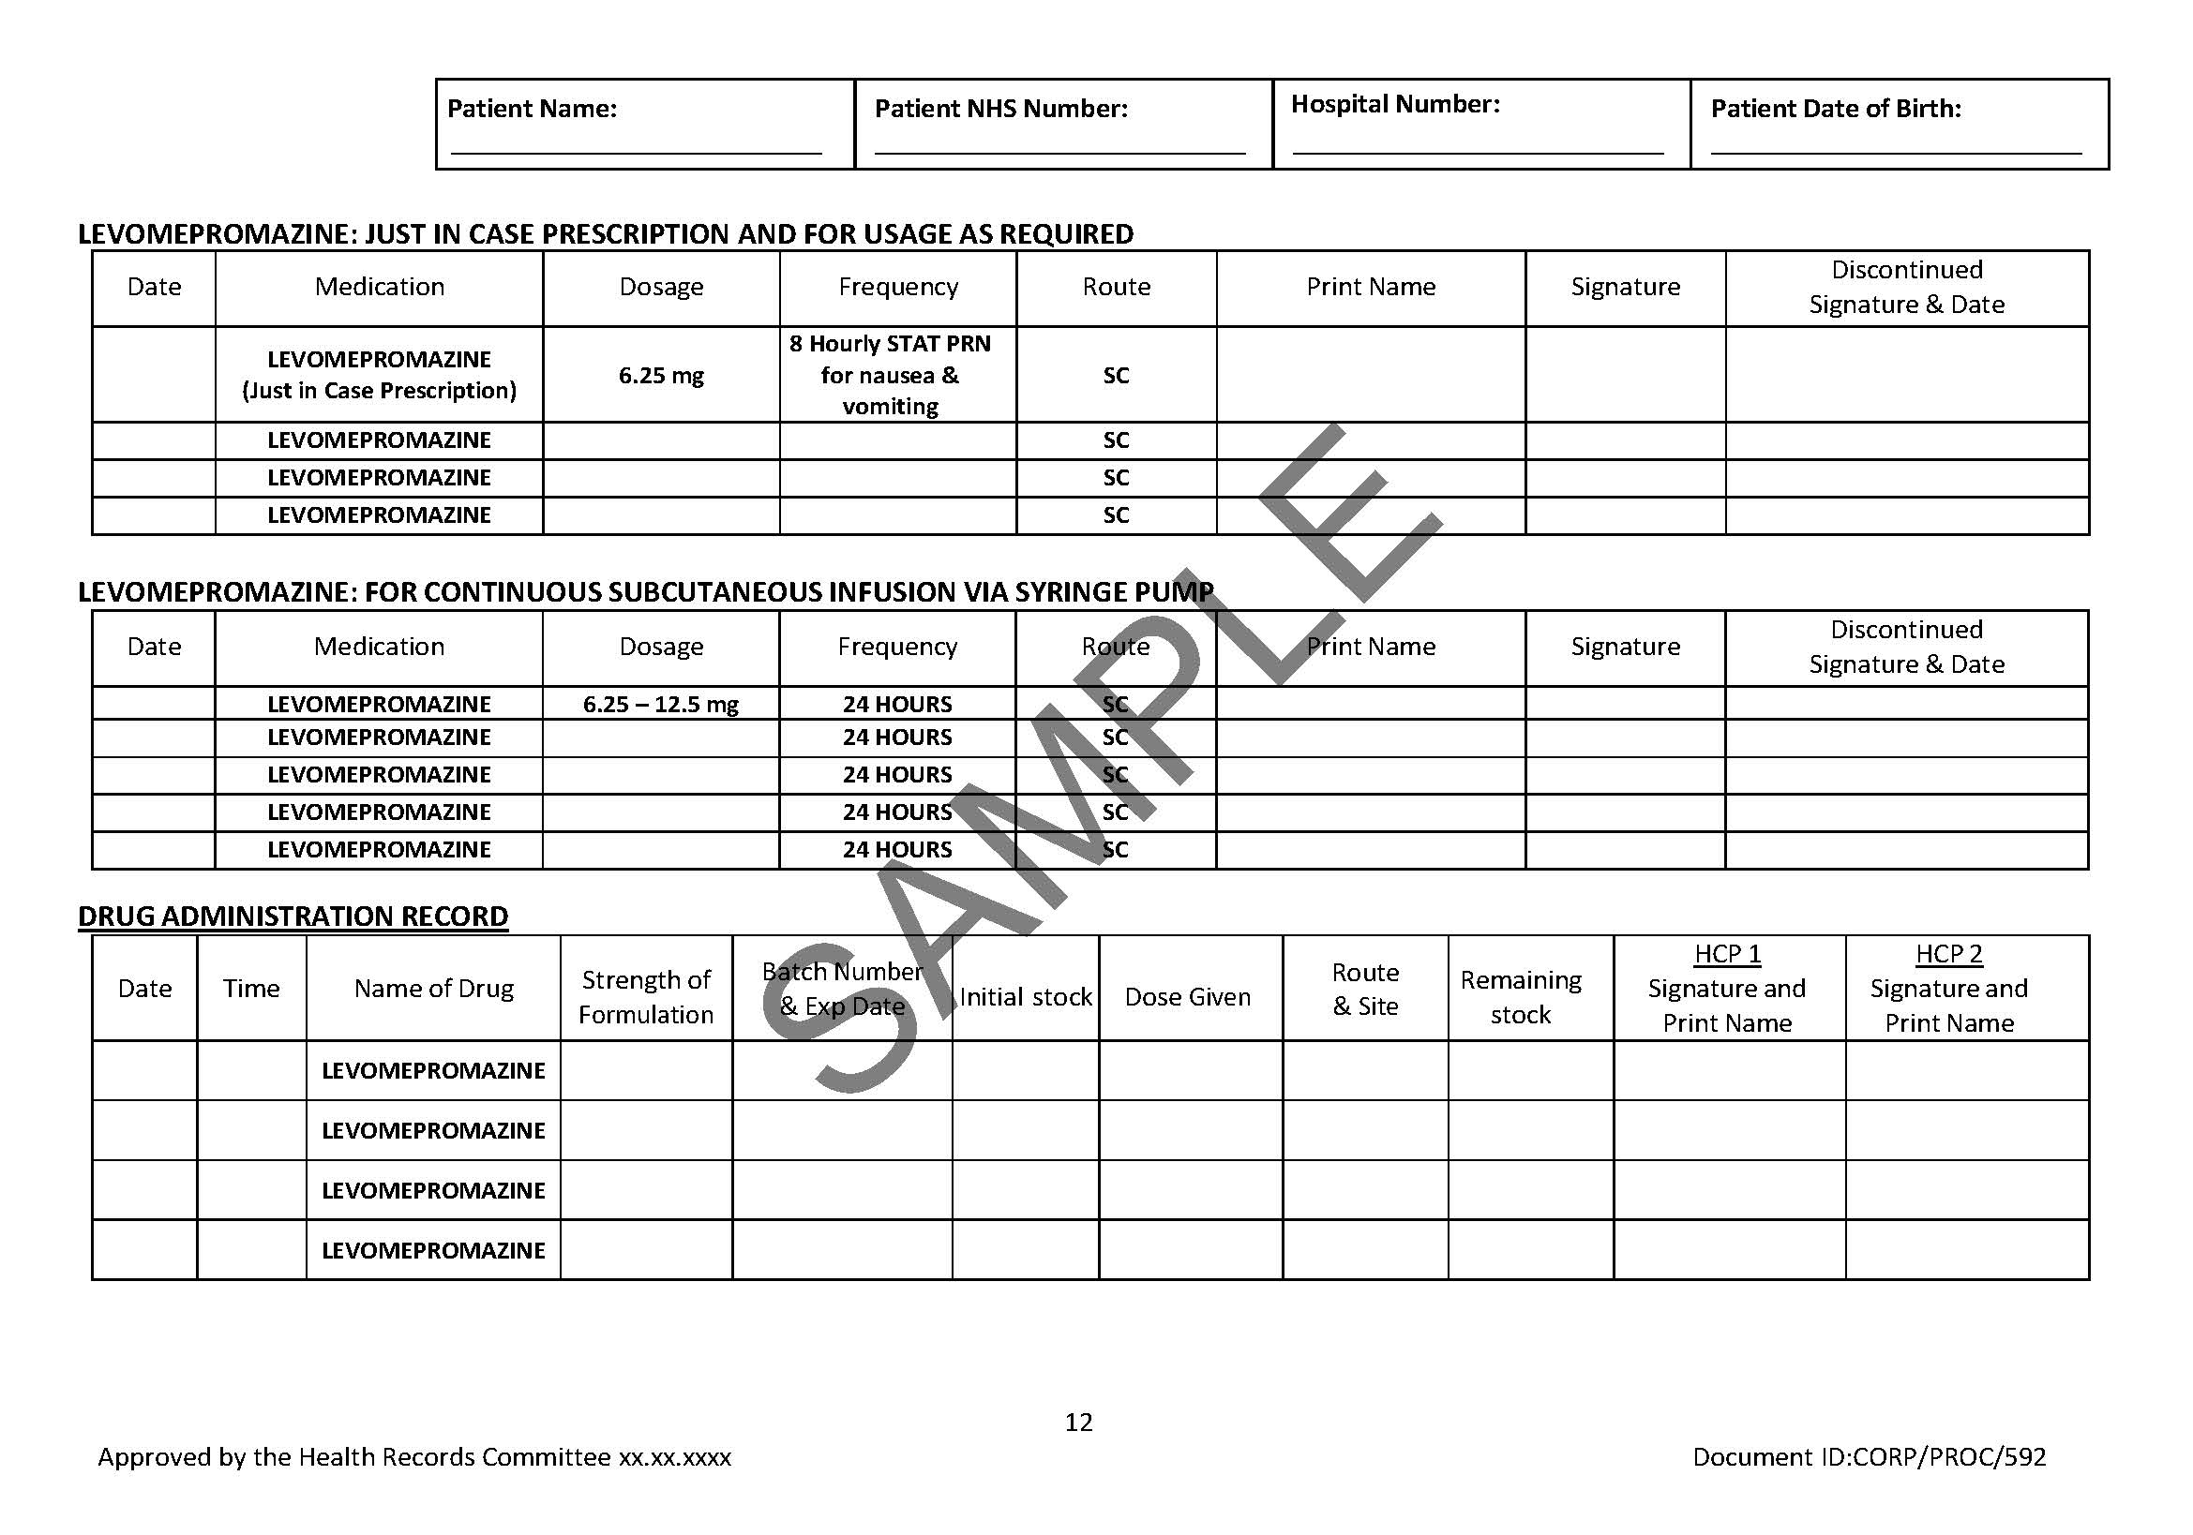
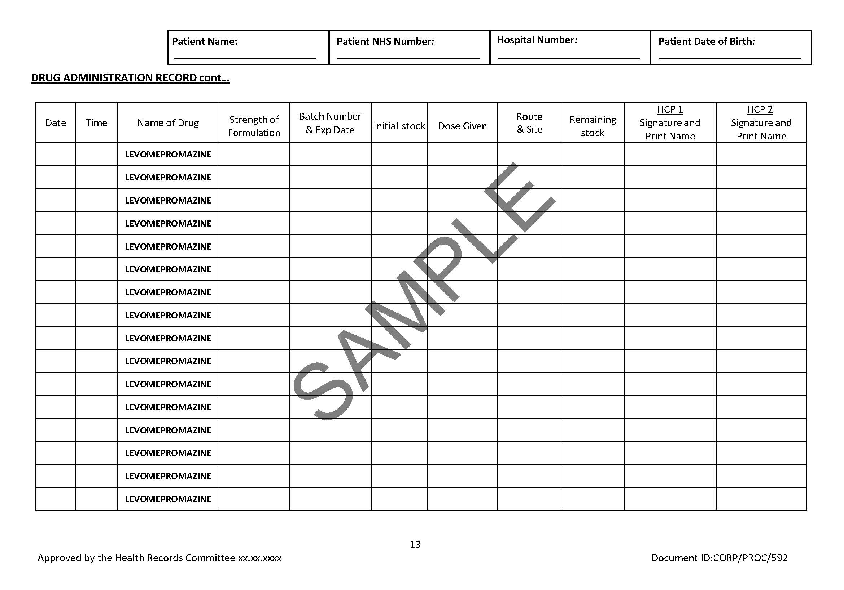
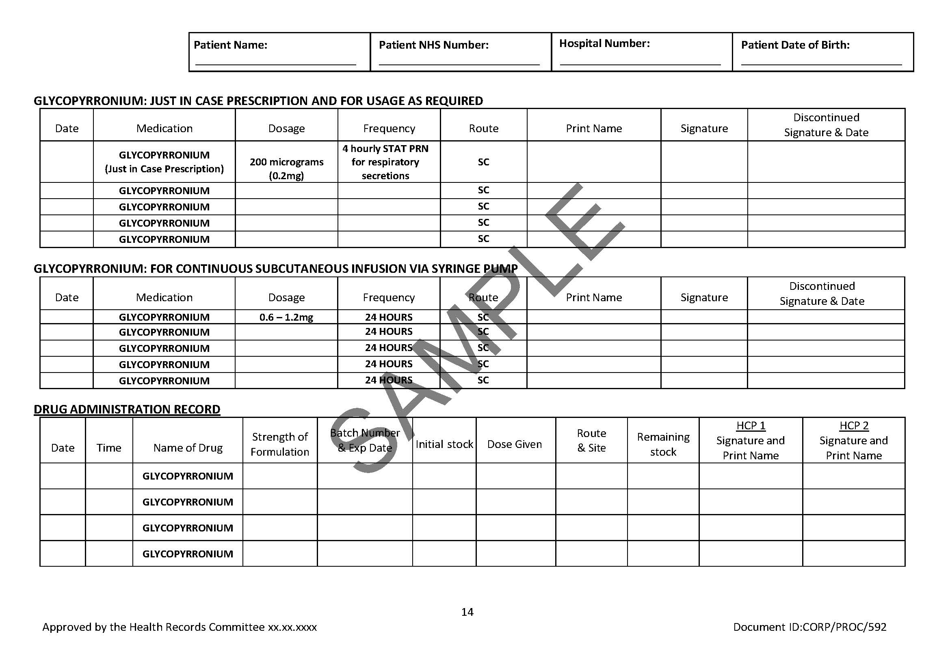
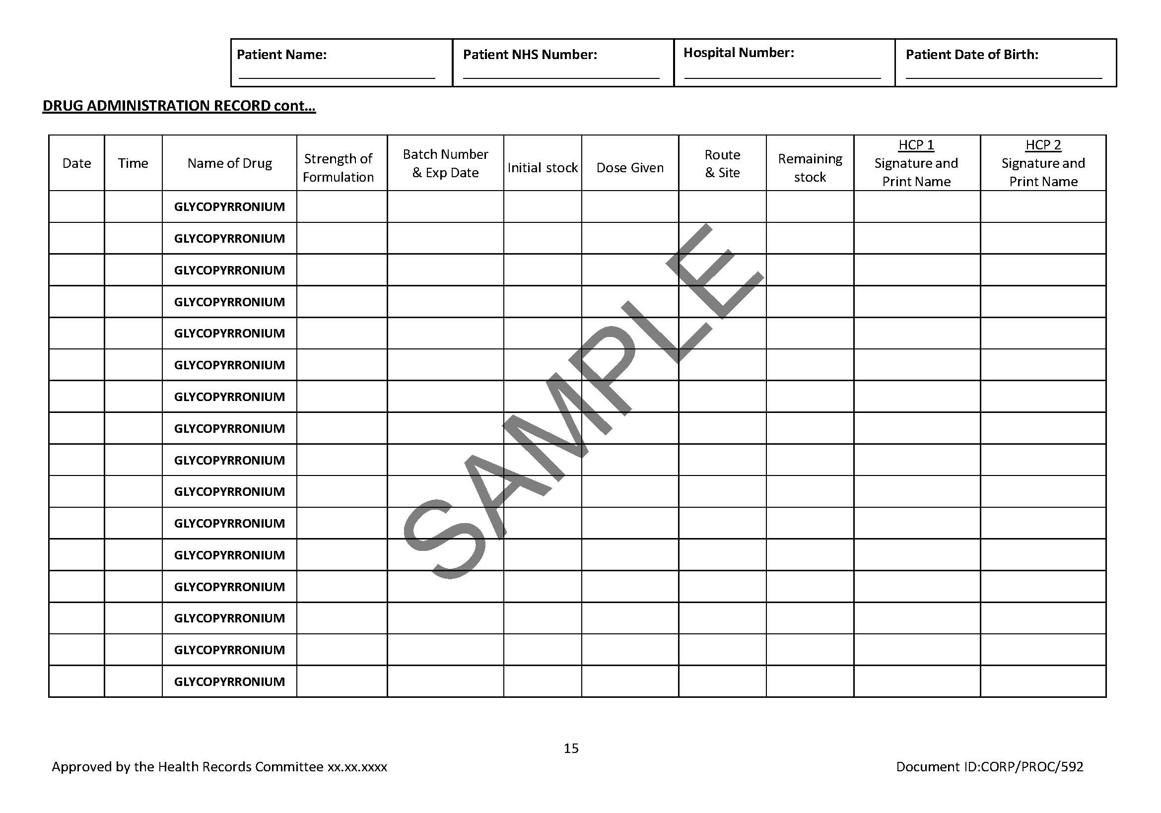
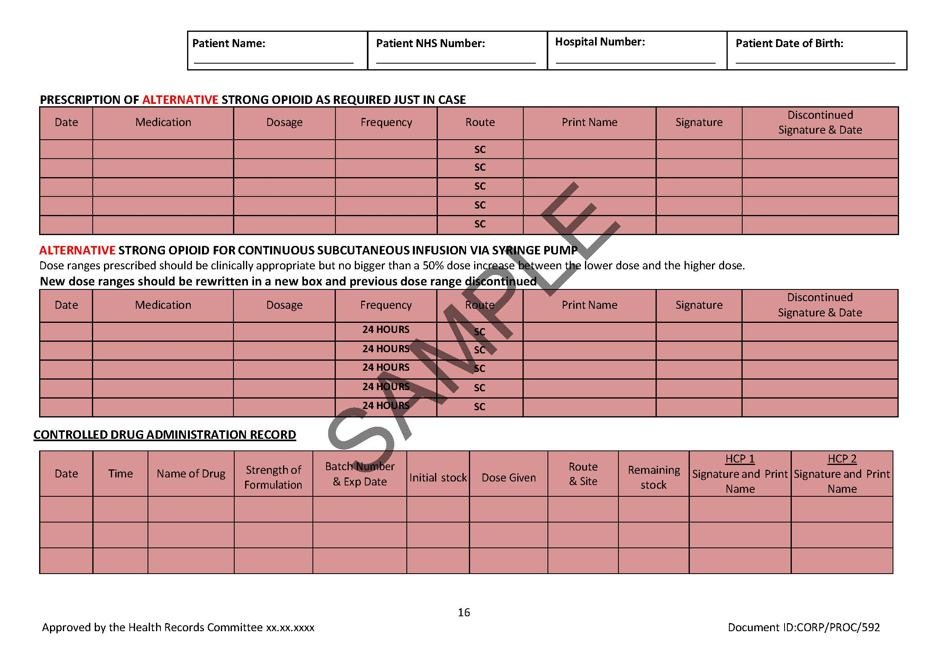
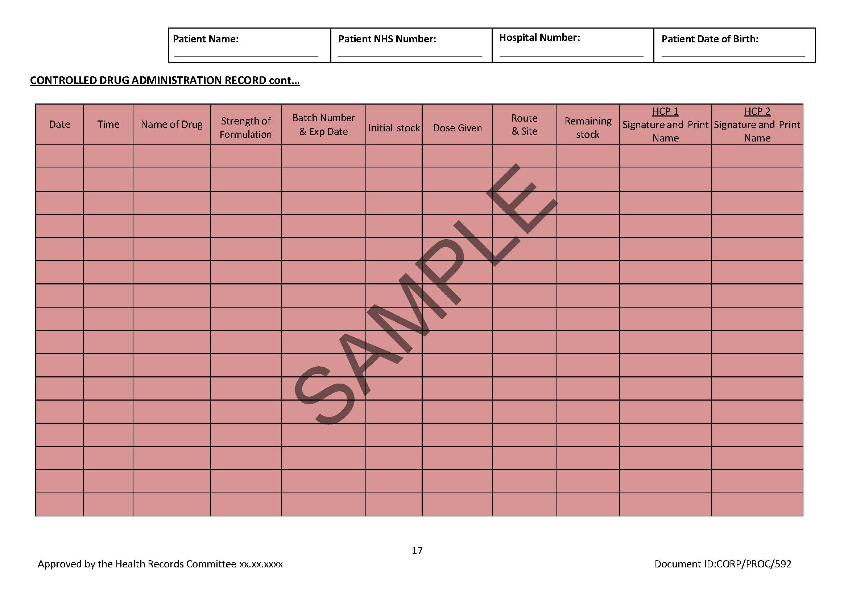
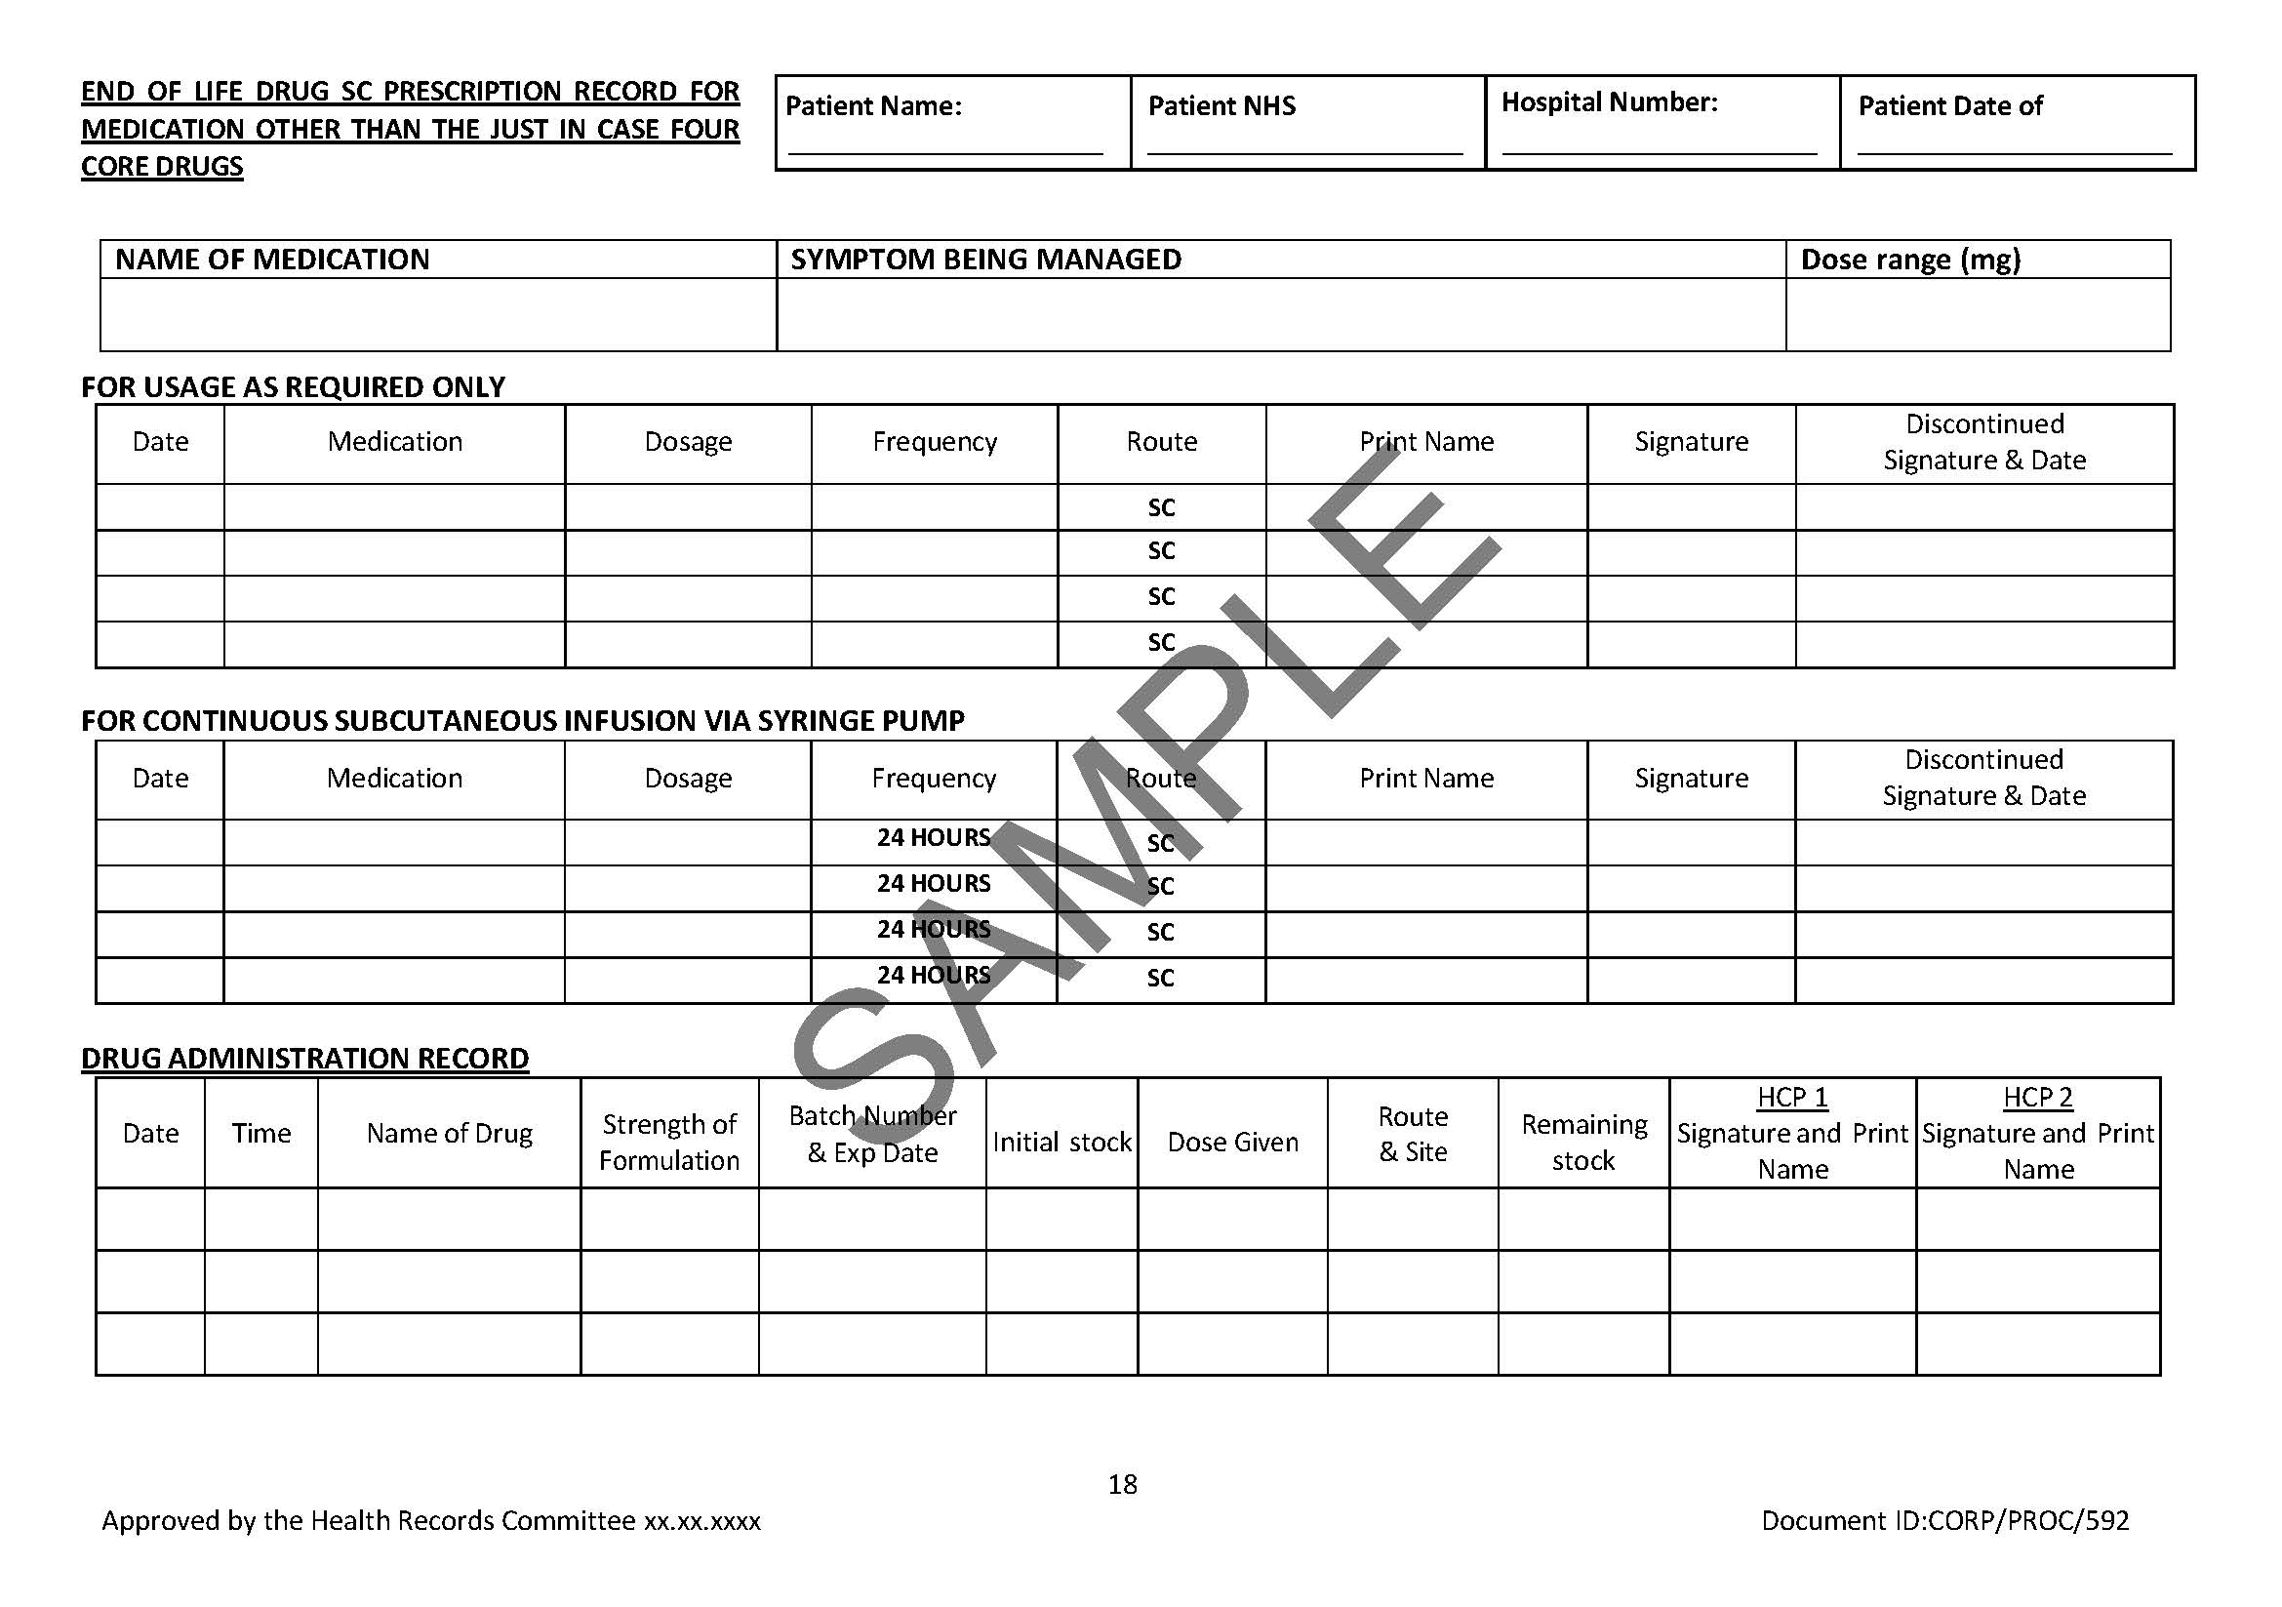
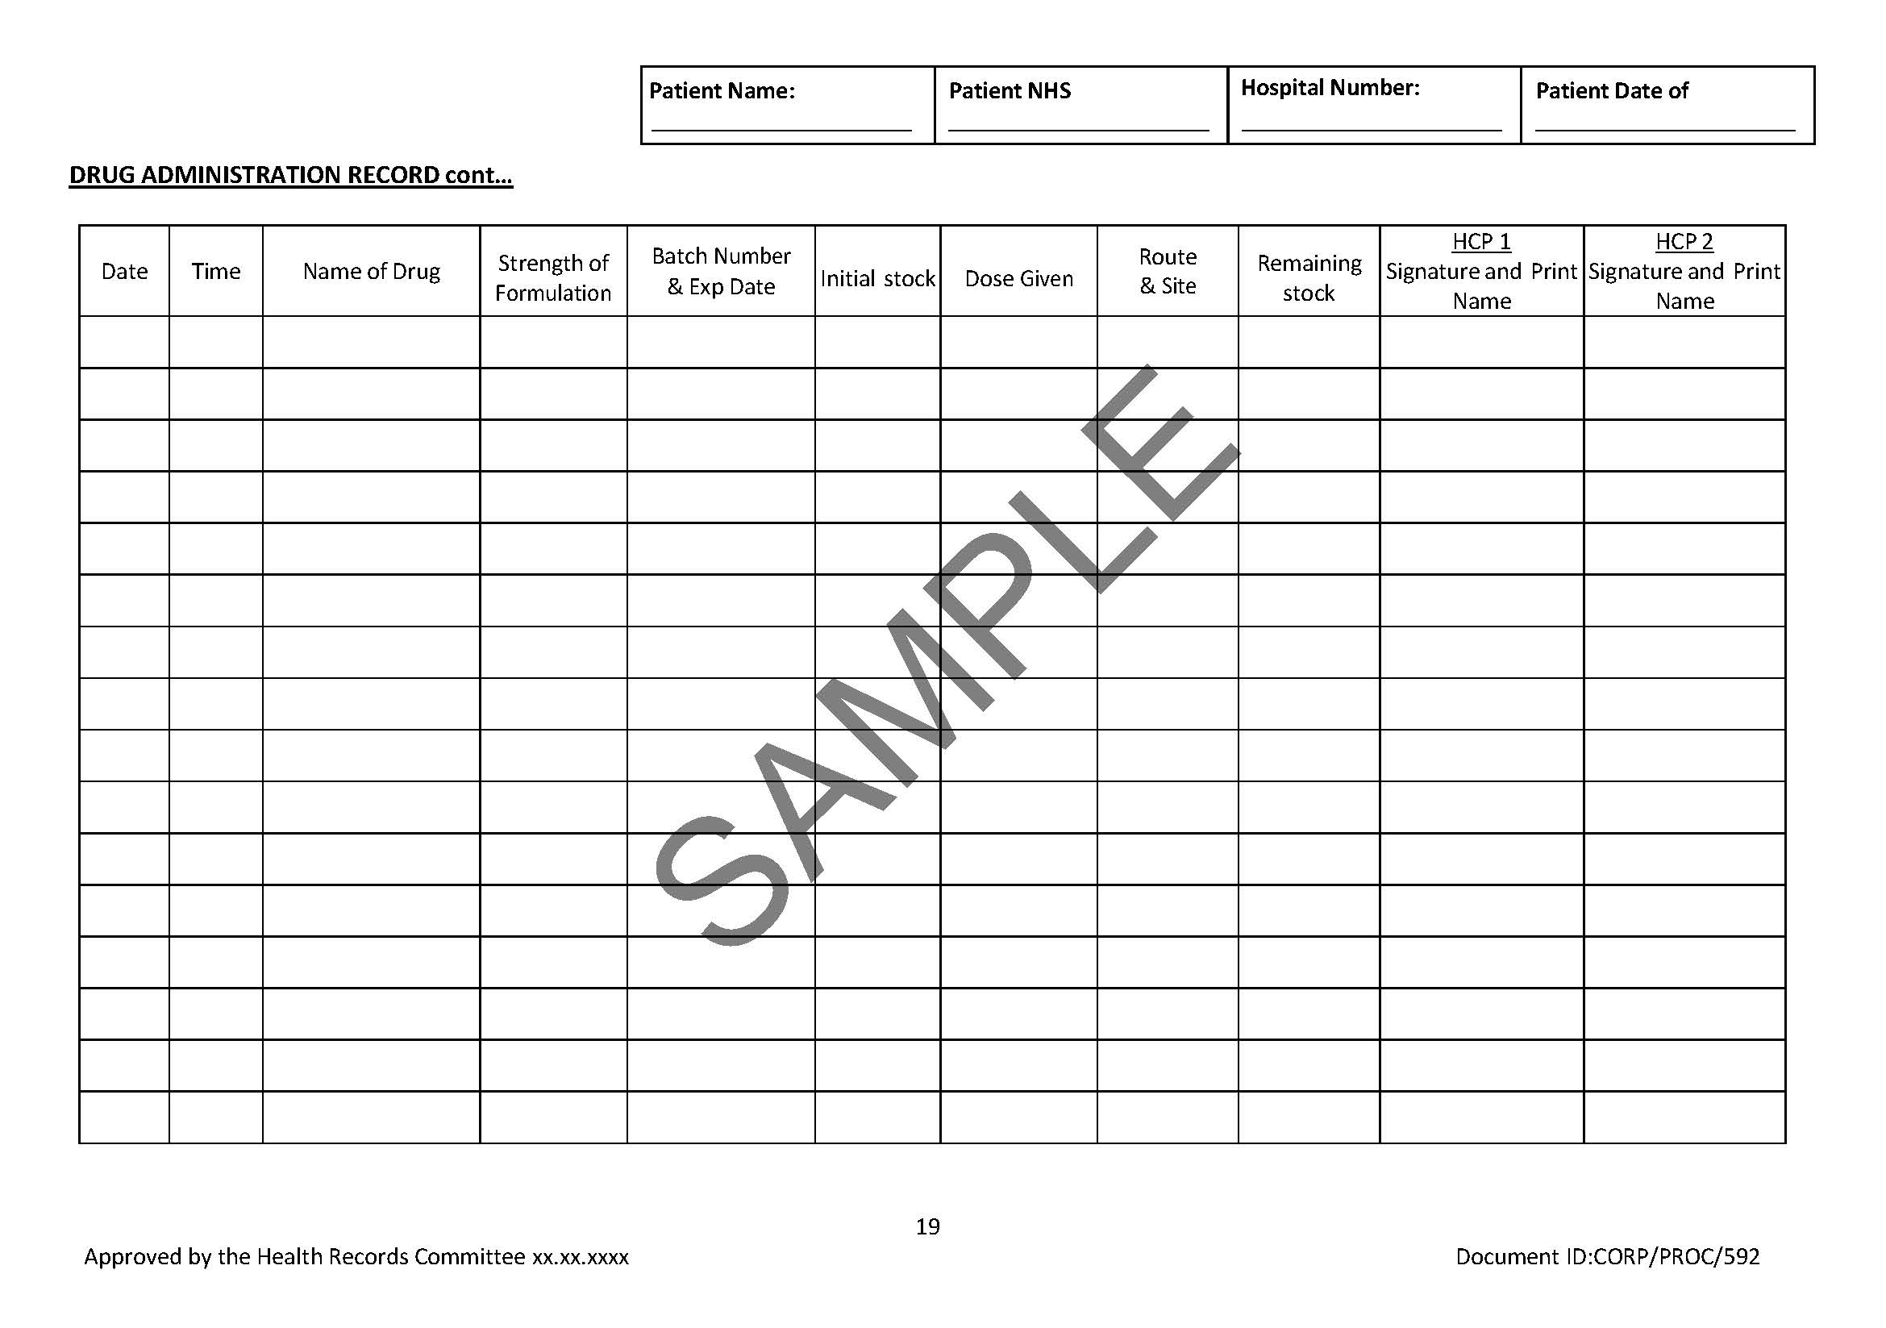
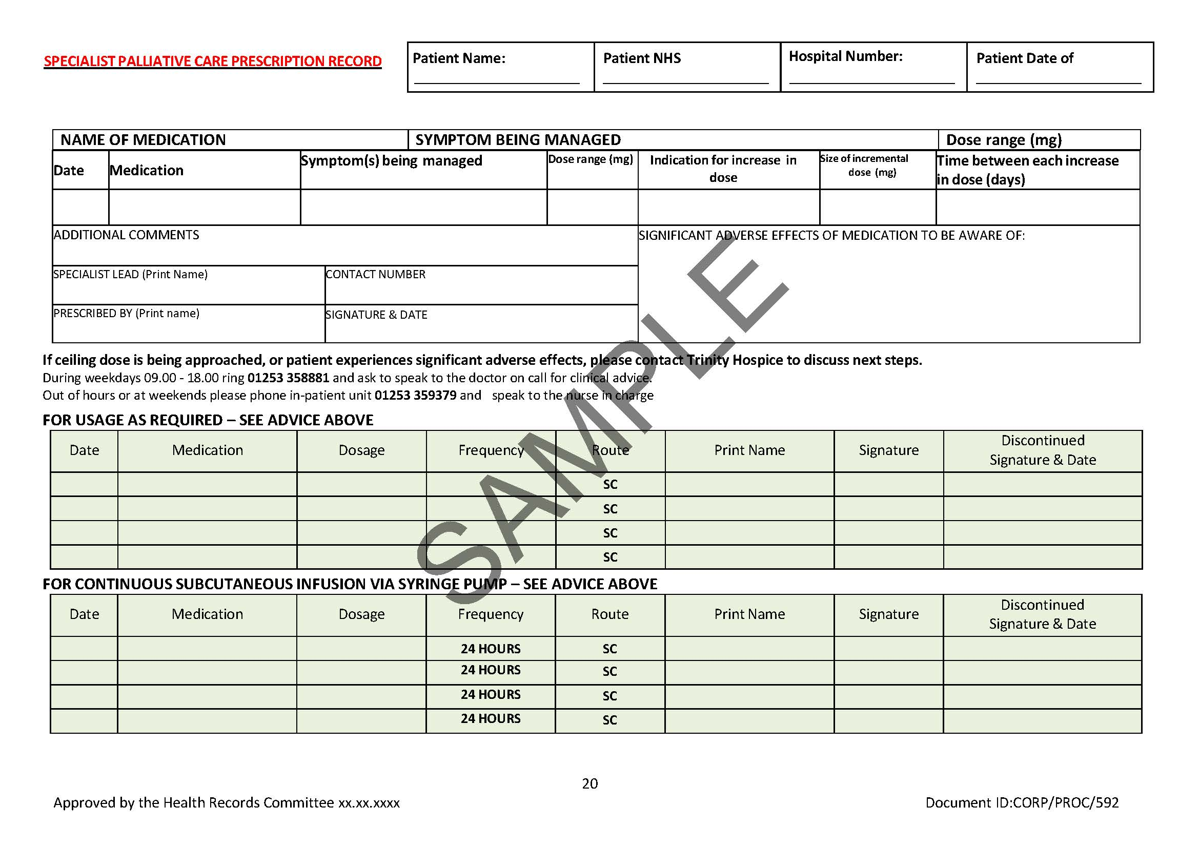
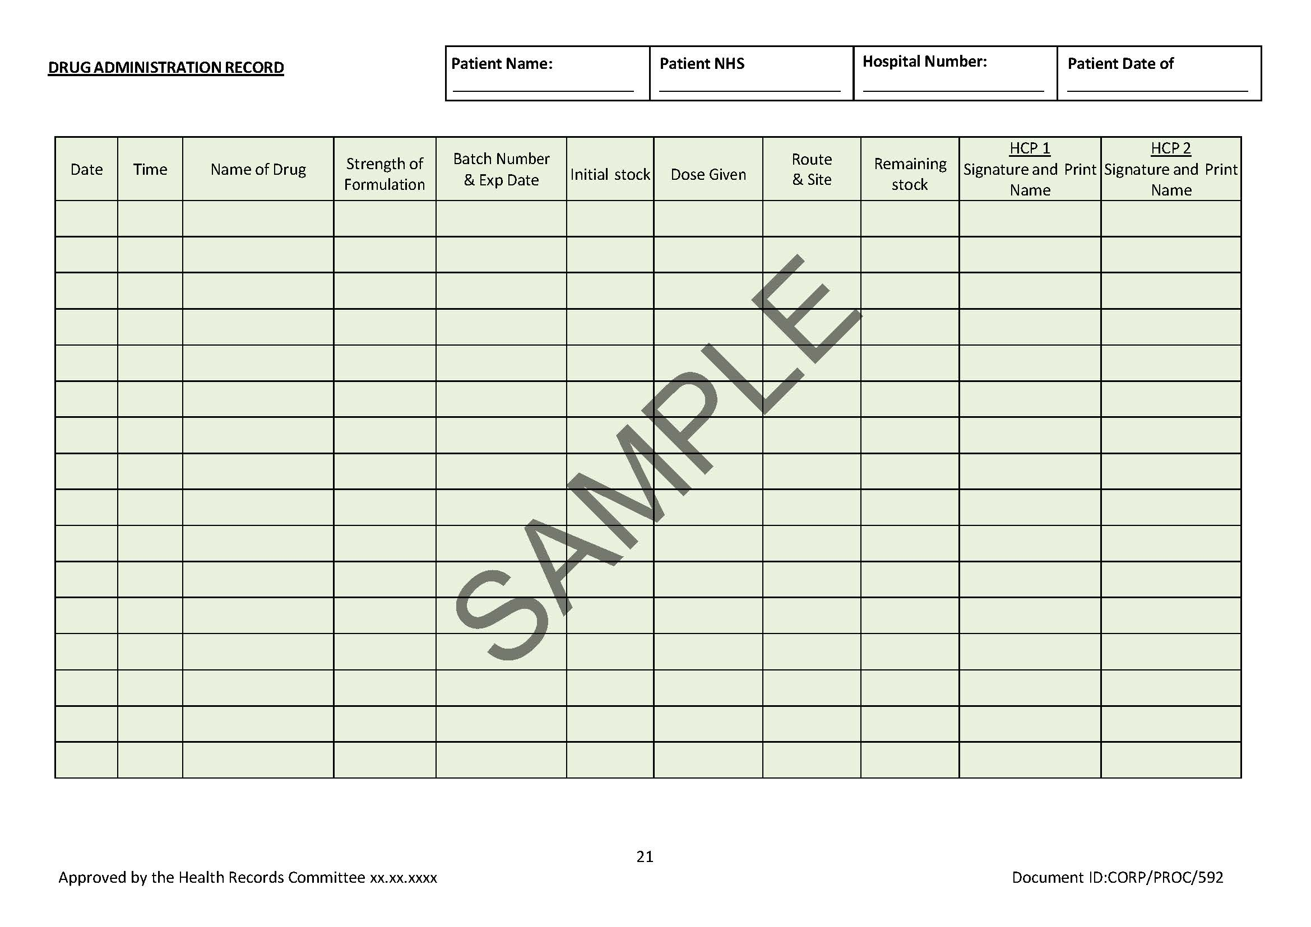
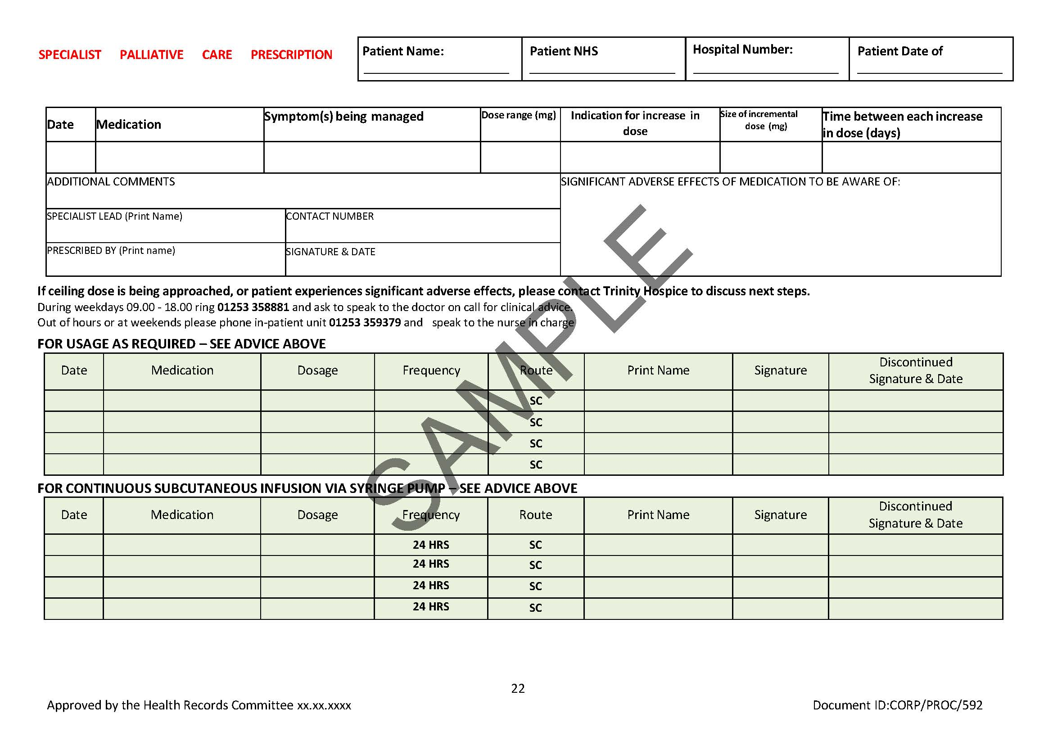
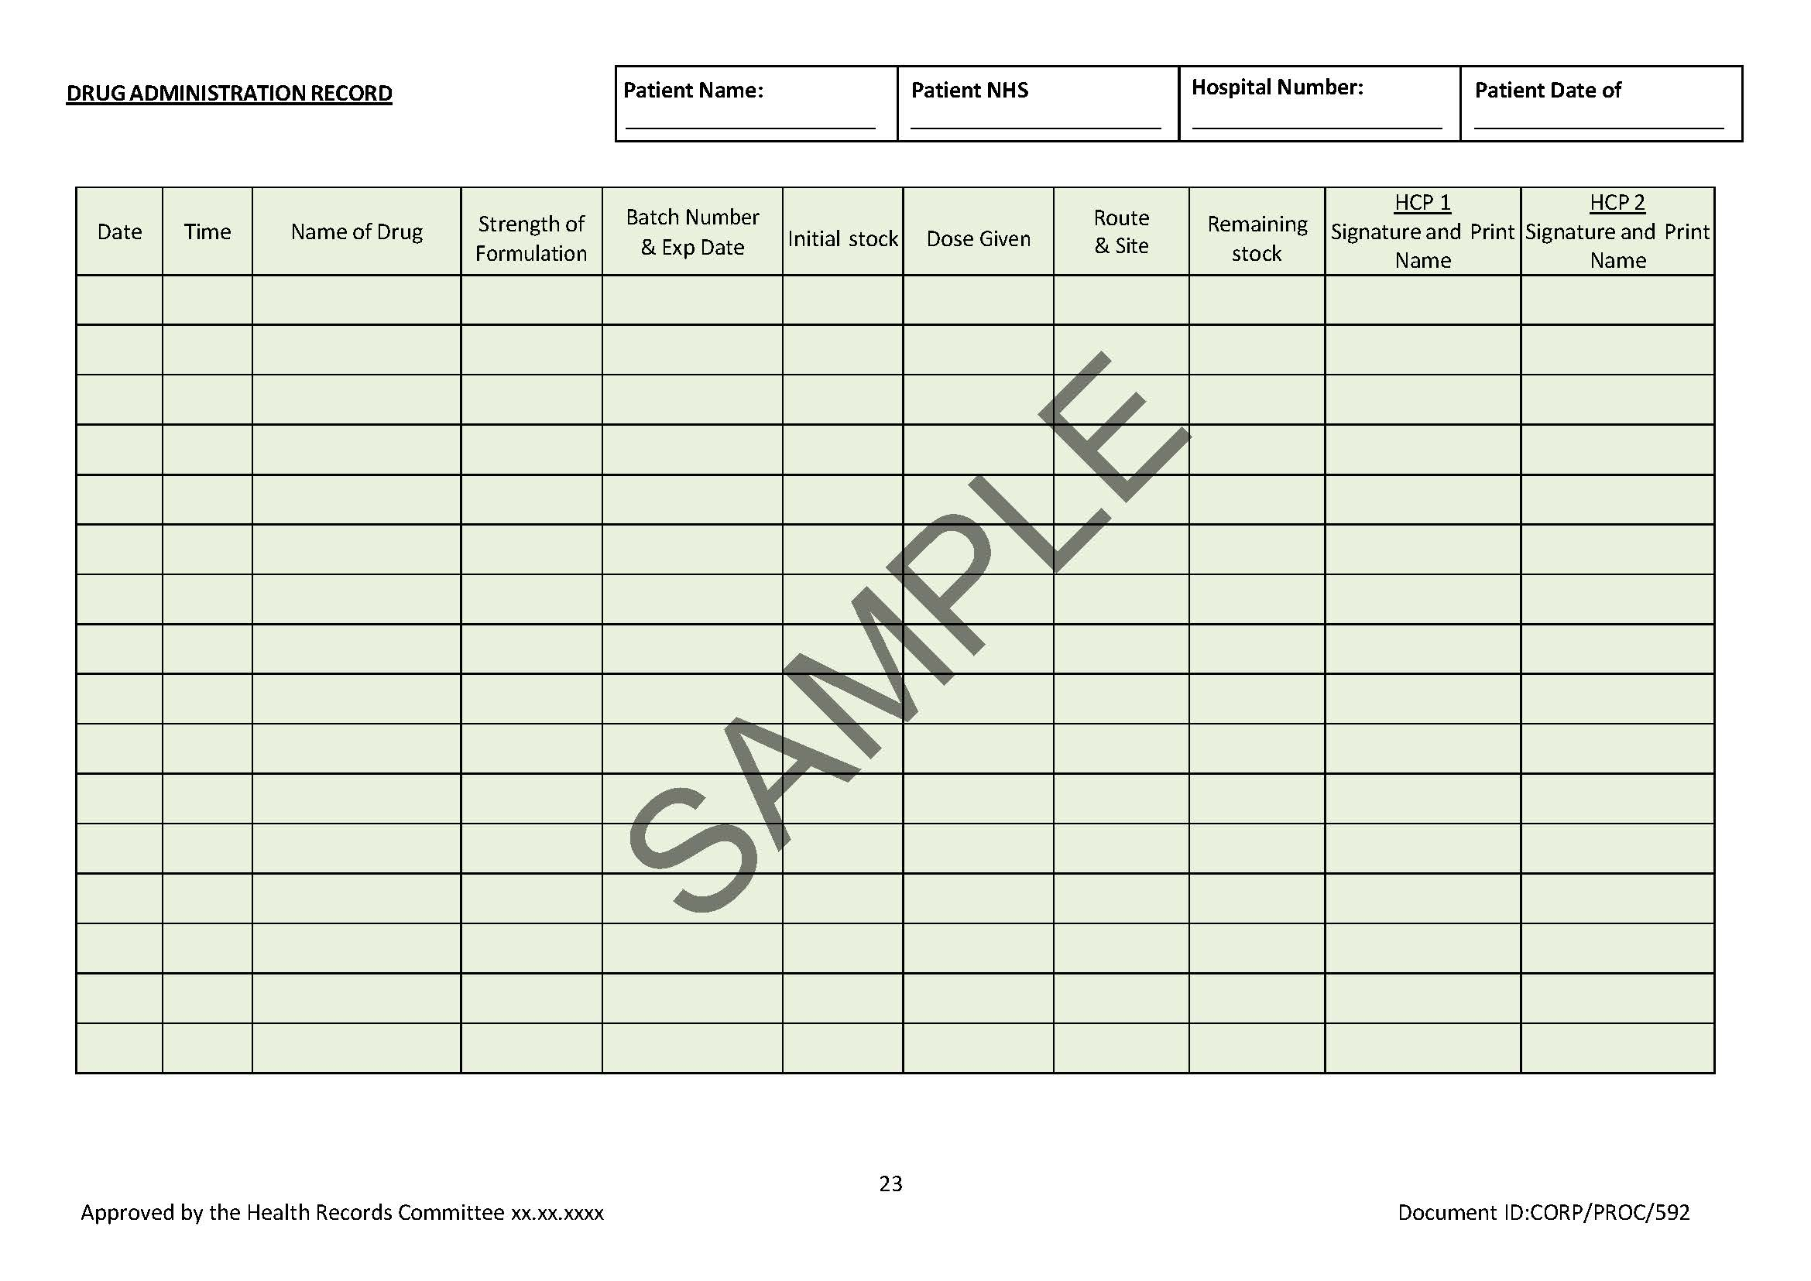

Appendix 1: Subcutaneous ‘as required’ & Syringe Pump Prescription Administration Record (SPAR booklet) See separate document
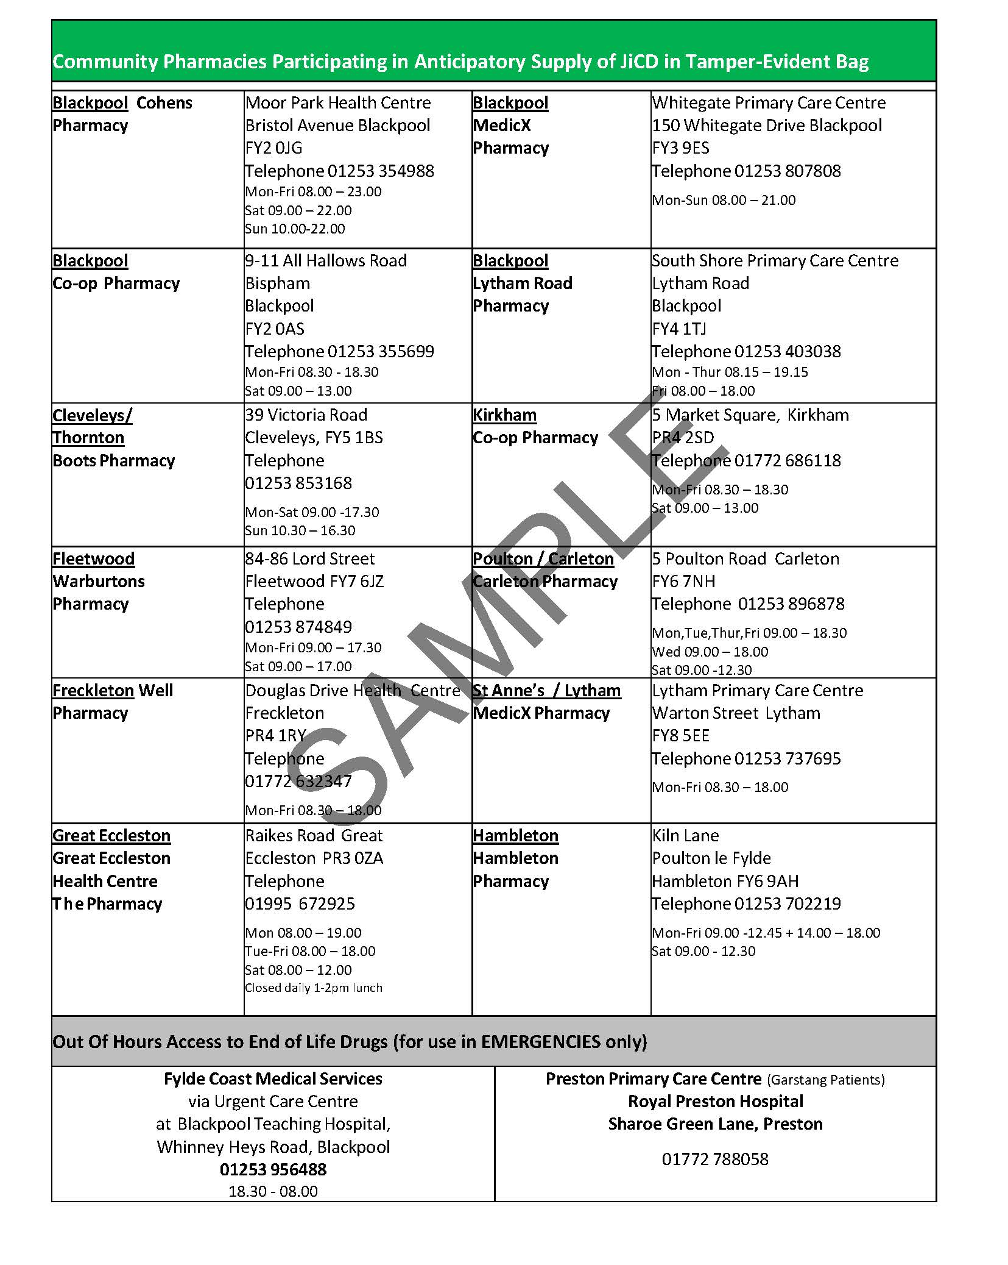

Appendix 2: Pharmacy Collection and Delivery Form for the JiCDs
(To be retained in the Pharmacy)

Name of Patient | Address of Patient | Date of Collection | Name of Person Collecting Medicine | Signature of Person Collecting Medication

Drug  SAMPLE | Quantity Dispensed | Batch Number | Expiry Date
Morphine 10mg/ml Inj | 10
Levomepromazine 25mg/mL Inj (1mL amps) | 5
Midazolam 5mg/mL Inj (2mL amps) | 10
Glycopyrronium bromide 200mcg/mL Inj | 10
Water for Injection 10mL amps | 10

Date Dispensed: ………………………………………………………..

Pharmacist Signature: …………………………………………………

Name of Pharmacist: …………………………………………………..

Appendix 3: Primary Care Flow Chart for the use of ‘Just in Case Four Core Drugs’
Need for prescribing is identified by GP/Community Nurse

Explanation to patients and carers of the purpose of the JiCDs and its use by District Nurses, Specialist Palliative Care Nurse or Doctor.
Give Leaflet about the JiCDs

Patient’s prescriber issues prescription for drugs to be included and marks prescription ‘JICD’ so pharmacist aware patient in the scheme
Prescriber also completes Subcutaneous ‘as required’ & Syringe Pump Prescription Administration Record (SPAR booklet)

Prescriber informs ‘out-of-hours services’ via Adastra Web and completed Community Care Plan

Medication is dispensed by designated Pharmacist into sealed labelled bag
(attaching 2nd dispensing label and noting the batch number/expiry date of the contents on the outside of the bag)

Pharmacist completes ‘collection and delivery form’

The JiCDs may be delivered by the Pharmacy or collected by the patient’s representative.
A registered nurse may act as the patient’s representative in exceptional situations as stated in the NMC guidelines (ID Needed)
The person collecting the JiCDs must sign and date the pharmacy ‘collection and delivery’ form

If the drugs are not used, the community nurse should check the seal is intact and the expiry dates of the drugs at least every four weeks.

If the seal is not intact and the drugs are being used record on the SPAR booklet
If the seal is not intact and the drugs are not being used, an untoward incident must be completed
If the seal is intact but the drugs have expired, they must be replaced via GP FP10.
If the seal is intact and the expiry dates are OK, no further action is needed

At the onset of symptoms, the stock levels should be checked and recorded on page 2 of the Subcutaneous ‘as required’ and Syringe Pump Prescription Administration Record
(SPAR booklet) by a healthcare professional

At onset of symptoms administer appropriate medication as prescribed
IN CASE OF RAPID DETERIORATION IN PATIENT’S
CONDITION OR SIGNIFICANT INCREASE IN SEVERITY OF
SYMPTOMS SEEK REVIEW BY DOCTOR

If the patient is admitted into hospital/hospice the administration record must go with the patient and be amended prior to discharge back to the community

Document any drugs administered on the Subcutaneous ‘as required’ & Syringe Pump Prescription Administration Record (SPAR booklet)

If symptoms persist, liaise with GP to establish medication needed for ongoing symptom control. If the patient is admitted into hospital/hospice the administration record must go with the patient and be amended prior to discharge back to the community

Medication from the JiCDs may be used to set up a syringe pump. However, it will be necessary to obtain further medication for the syringe pump as soon as possible.
Please refer to syringe pump policy in this instance

Following the patient’s death, any remaining drugs must be destroyed according to local guidance
The Subcutaneous ‘as required’ & Syringe Pump Prescription Administration Record (SPAR booklet)
must be retained with the patient’s notes for the period specified in Records Management NHS Code of Practice Part 2 (2nd Edition) 2009
The Feedback form should be completed by the appropriate DN and returned to the address on the form

Appendix 4: Flow Chart for ‘Just in Case Four Core Drugs’ in Hospital or Hospice
Need for prescribing is identified. Pharmacy must be alerted to rapid discharge

Hospital prescriber issues paper discharge prescription for controlled drugs and e-discharge TTO for other drugs, including Water for Injections.
Prescriber also completes Subcutaneous ‘as required’ & Syringe Pump Prescription Administration Record (SPAR booklet)
TTO and SPAR booklet to be sent to Pharmacy

Primary Health Care Team informed of patient’s discharge with anticipatory drugs.
(Hospital prescriber informs GP on Hospital Discharge Summary
and Ward Nurse informs District Nursing Service on DN Referral Form
so that Primary Health Care Team can inform ‘out-of-hours services’ via Adastra)

Medication is dispensed by Pharmacy into sealed labelled bag
(attaching 2nd dispensing label and noting the batch number/expiry date
of the contents on the outside of the bag)

Pharmacist completes ‘collection and delivery form’

The JiCDs are released by the Pharmacy to the ward.
The nurse collecting the JiCDs from the Pharmacy must sign and date the appropriate documentation.

Explanation to patients and carers of the purpose of the JiCDs and its use by Ward Nurses, Specialist Palliative Care Nurse or Doctor.
Sealed Bag containing JiCDs, SPAR booklet and Patient Information Leaflet are given to the patient / patient’s representative, along with other discharge medications, on discharge from hospital.

Community Flowchart (see Appendix 4) to be followed from when patient arrives home with regards to checking, administration and destruction of JiCDs

JiCD Drugs on Admission to Hospital / Hospice

JiCDs and SPAR booklet should be taken with patient if admitted to hospice or hospital

JiCDs should be destroyed by hospital / hospice, in accordance with local policy
SPAR booklet should be stored in patients’ medical records during admission

During in-patient admission, subcutaneous medications (both syringe pump and ‘as required’) should be prescribed on hospital / hospice in-patient prescription, in accordance with local policy

If patient dies during admission,
SPAR booklet must be retained with the patient’s hospital / hospice notes for the period specified in Records Management NHS Code of Practice Part 2 (2nd Edition) 2009

Prior to discharge,
SPAR booklet should be amended
in accordance with supplied
discharge subcutaneous medications
(both syringe pump and ‘as required’)

Discharge medications and SPAR booklet are given to the patient / patient’s representative on discharge from hospital.

The Feedback form should be completed by Primary Health Care Team (District Nurse)
and returned to the address on the form

Appendix 5: Equality Impact Assessment Form
Department | Pharmacy |  |  | Service or Policy | CORP/PROC/592 |  |  | Date Completed: |  |  |  | 25/05/2015
GROUPS TO BE CONSIDERED
Deprived communities, homeless, substance misusers, people who have a disability, learning disability, older people, children and families, young people, Lesbian Gay Bi-sexual or Transgender, minority ethnic communities, Gypsy/Roma/Travellers, women/men, parents, carers, staff, wider community, offenders.
EQUALITY PROTECTED CHARACTERISTICS TO BE CONSIDERED
Age, gender, disability, race, sexual orientation, gender identity (or reassignment), religion and belief, carers, Human Rights and social economic / deprivation.
QUESTION |  |  | RESPONSE |  |  |  |  |  |  | IMPACT
 |  |  | Issue |  |  | Action |  |  |  | Positive |  |  |  | Negative
What is the service, leaflet or policy development?  What are its aims, who are the target audience? |  |  | See Purpose
Does the service, leaflet or policy/ development impact on community safety  - Crime  - Community cohesion |  |  | No
Is there any evidence that groups who should benefit do not? i.e. equal opportunity monitoring of service users and/or staff. If none/insufficient local or national data available consider what information you need. |  |  | No
Does the service, leaflet or development/ policy have a negative impact on any geographical or sub group of the population? |  |  | No
How does the service, leaflet or policy/ development promote equality and diversity? |  |  | No
Does the service, leaflet or policy/ development explicitly include a commitment to equality and diversity and meeting needs? How does it demonstrate its impact? |  |  | No
Does the Organisation or service workforce reflect the local population? Do we employ people from disadvantaged groups |  |  | No
Will the service, leaflet or policy/ development  - Improve economic social conditions in  deprived areas  - Use brown field sites  - Improve public spaces including creation of green spaces? |  |  | No
Does the service, leaflet or policy/ development promote equity of lifelong learning? |  |  | No
Does the service, leaflet or policy/ development encourage healthy lifestyles and reduce risks to health? |  |  | No
Does the service, leaflet or policy/ development impact on transport?  What are the implications of this? |  |  | No
Does the service, leaflet or policy/development impact on housing, housing needs, homelessness, or a person’s ability to remain at home? |  |  | No
Are there any groups for whom this policy/ service/leaflet would have an impact? Is it an adverse/negative impact? Does it or could it (or is the perception that it could exclude disadvantaged or marginalised groups? |  |  | No
Does the policy/development promote access to services and facilities for any group in particular? |  |  | No
Does the service, leaflet or policy/development impact on the environment  - During development  - At implementation? |  |  | No
ACTION:
Please identify if you are now required to carry out a Full Equality Analysis |  |  |  |  |  |  | Yes |  | No |  | (Please delete as appropriate)
Name of Author:  Signature of Author: |  | Dr Andrew Dickman / Dr Susan Salt |  |  |  |  |  |  | Date Signed: |  |  |  | 25/05/2015
Name of Lead Person:  Signature of Lead Person: |  |  |  |  |  |  |  |  | Date Signed:
Name of Manager:  Signature of Manager |  |  |  |  |  |  |  |  | Date Signed:

